A translational case study of empowerment into practice: An evaluation of the Dementia NI Service

March 2018

School of Social Sciences, Education and Social Work
Queen’s University Belfast

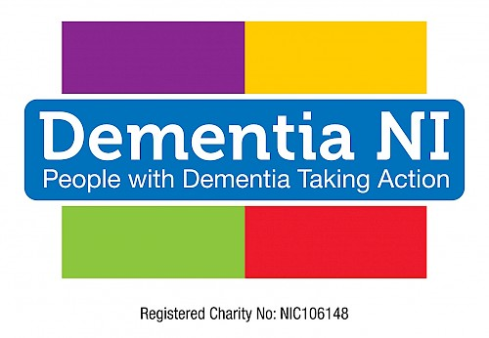

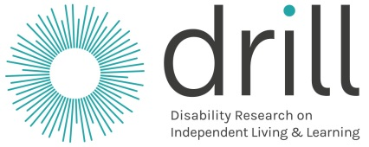
Summary
A recent report by the World Health Organisation (WHO) and Alzheimer’s Disease International suggested that the number of people living with dementia will triple by 2050. A key objective of the G8 Dementia Summit (UK) is to improve treatment and preventive methods, and improve the quality of life of people living with dementia. This report presents the story of the development of a new initiative –Dementia NI – and the extent to which it has contributed to the goal of improving the quality of life of people living with the disease. Although often, people with dementia are referred to as ‘suffering’, or as ‘brave battlers’ of a ‘debilitating illness’, there is a growing movement that focuses on ‘living well with dementia’ and recognising that people with dementia have strengths as well as challenges and vulnerabilities.
Initiatives aimed at empowering people living with dementia and improving their quality of life are being implemented worldwide. These initiatives mark a ‘new wave’ of people with dementia who are working collectively to counter the negative stigma surrounding the illness and portrayals of people with dementia as incapable of independent living, or making decisions about issues that affect them.
This report presents the results of an evaluation of Dementia NI - an organisation founded by people living with dementia and based on the concept of empowerment. The evaluation attempted to add to our understanding about what works regarding empowerment-driven initiatives and which factors facilitate such initiatives.
The key take away message from this evaluation is that empowerment-based initiatives, or models of self-support, provide an opportunity for people with dementia to develop a shared social identity and a sense of social power. This experience generates motivation to access required resources and enables people with dementia to raise awareness, challenge stigma, and have a voice in relation to issues that affect them. Initiatives such as Dementia NI appear to empower people living with dementia and improve their overall quality of life.
This evaluation was funded by Disability Research on Independent Living and Learning (DRILL), a Programme funded by the Big Lottery Fund.

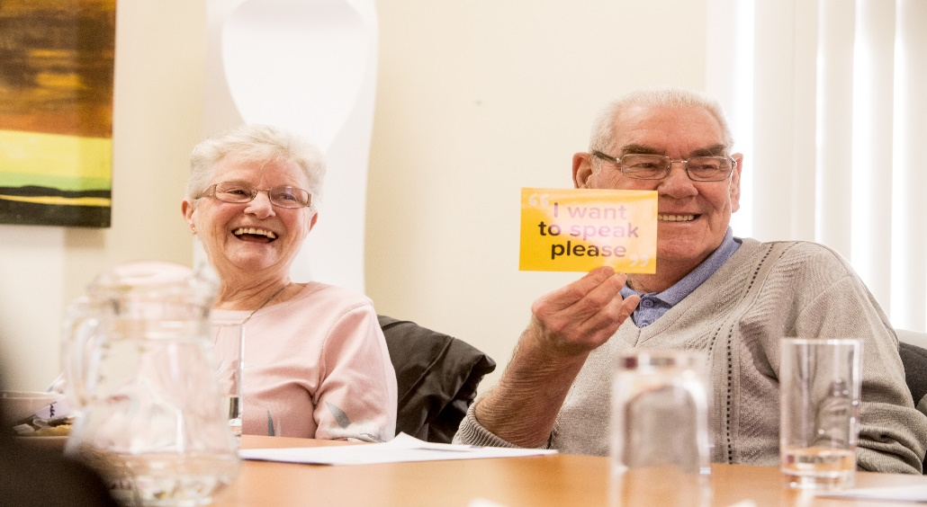
Table of Contents

Summary i

Introduction 1

Background to the evaluation 2

Rationale for the study 3

Aims of the study 3

Methodology: realist evaluation 4

Methods 4

Sample 4

Qualitative Data Collection 6

Analysis 6

Results 7

Discussion 21

Conclusions/lessons learned 24

References 27

Introduction

On 15 January 2015 Dementia NI was founded by five people living with a diagnosis of dementia. The goal was to provide a voice for people who are living with this diagnosis. This unique organisation continues to be led by people with dementia who are developing empowerment groups across Northern Ireland. These groups are based on a model of empowerment whereby people with this diagnosis meet regularly in groups to help influence policy, practice and service delivery to meet local needs.

Dementia NI have a number of key aims which include challenging the stigma of having a diagnosis by raising awareness about dementia; promoting the rights of people living with dementia to influence policy, practice and service delivery across Northern Ireland; providing training, education and awareness to organisations and the public on how to live well with dementia; and supporting people living with dementia to lobby and raise awareness of dementia in their own right.

Dementia NI is different from more traditional advocacy organisations because it was set up to enable and empower people living with dementia, by people with dementia. The group came together through the Alzheimer’s Society and decided they wanted to do more than be in an activity group or a recipient of a care service. The ethos of the organisation is a positive message - that people with dementia can live well with the right support.

Established groups meet fortnightly, with new groups meeting on a monthly basis. Membership is only available to people with a diagnosis of dementia and can involve attending empowerment group meetings, as well as representing the charity at external events, meetings and conferences.

The charity has two Empowerment officers who cover all five Trust areas between them. Dementia NI aim to develop at least 2 empowerment groups in each health trust area; and to develop as a sustainable organisation. The charity is funded by Atlantic Philanthropies (AP) for 2 years and will seek to secure funding and income after AP funding ends.

The charity is involved in many areas to raise awareness about dementia, e.g. they encourage members to tell their experiences of receiving a diagnosis and post-diagnostic support, supporting others in similar situations, meeting with politicians; attending conferences; and trying to make communities, media, and environments more dementia-friendly.

There follows a scientific report of the evaluation conducted by the research team at Queen’s University Belfast.

Background to the evaluation

Approximately 46.8 million people worldwide have dementia, with numbers projected to double over the next 20 years (Prince et al, 2015). Living Well with Dementia (2009) outlines various UK government goals but arguably lacks substance in terms of giving voice and leadership opportunities for people with dementia. Involving people with dementia in decision making is widely accepted as a means of preserving autonomy, rights and personhood though we lack good evidence about the most effective, person-centred ways in which to achieve meaningful involvement, particularly involvement that is initiated and led by people with dementia and that relate to decisions regarding independent living. A recent review (Miller et al, 2014) found that while service users with dementia wanted to participate in decisions about, for example, their treatment and care, the actual level of involvement was limited and declined considerably as dementia progressed beyond mild cognitive impairment.

It is these kinds of translational challenges, issues and problems that Dementia NI, a newly established organisation initiated and led by people with dementia, are attempting to, and have addressed. The ethos of the organisation centres on empowerment and enablement by facilitating leadership opportunities and independence. ‘Empowerment Groups’ meet regularly to provide peer support and to promote better practice in relation to dementia care.

Rationale for Study

External Evaluation of Dementia NI

Dementia NI has successfully established a partnership with Queen’s University Belfast to provide an external evaluation of the Dementia NI organisation and its impact.
Queen’s University Belfast secured funding from Disability Research on Independent Living & Learning (DRILL) (link to website: http://www.drilluk.org.uk/) to employ a research assistant to provide a more in depth research evaluation on the impact of empowerment and people with dementia.

Aims of the study

This evaluation helps identify and explain what it is about Dementia NI that works, how it works, and what increases the likelihood that the organisation will meet its intended outcomes. To do this we asked the following questions.
What processes and circumstances help/hinder Dementia NI to meet their intended outcomes, including:
- Improving quality of life for members?
- Better informing policy-makers and service providers?
- Increasing involvement of people with dementia?
- Shaping services?
- Improving public awareness and understanding = reducing stigma/greater social inclusion?

Methodology: realist evaluation

Realist evaluation is well-established within the health and social care service delivery field (Greenhalgh et al, 2009). This approach was chosen based on its flexibility and suitability in relation to evaluating Dementia NI, based on their stated aims and objections. Within the realist method, quantitative and qualitative data collection measures are utilised, including interviews and observations conducted across different time points, thereby allowing us to match up findings to ensure they are both accurate and reliable

A core principle of realist evaluation is that programmes work differently depending on the context into which they are introduced. For example, if the context is right, it will trigger the mechanisms required for success, if not these mechanisms will remain dormant. In realist evaluation, mechanisms refer to service users’ mental processes (thoughts and feelings): in response to resources offered by an intervention that leads to behaviour change (observable/measurable outcomes). Therefore, realist evaluation is an appropriate method for studying empowerment initiatives for people with dementia which involve numerous strategies implemented across varied contexts.

Methods

As in all realist approaches, our evaluation began by developing an initial program theory in relation to how Dementia NI was believed to ‘work’. We did not aim to determine effectiveness per se but rather we developed a refined program theory that would help answer what works, for whom, in what circumstance, why and how.

Sample

Following ethical approval from the School of Social Sciences, Education and Social Work’s Research Ethics Committee, all current users (n=15), staff (n=3) and board members (n=5) of Dementia NI were contacted via email by two members of the research team in order to organize semi-structured interviews and observations. We collected written informed consent before interviews and observations were carried out. Our observational engagement with Dementia NI took place in Empowerment Group meetings, public events they contributed to, and in attendance of board meetings. Exclusion criteria included those unwilling or unable to give informed consent.

Table 1: Sample for interviews
Who took part? | How many?
Dementia NI Members | 15
Dementia NI Staff | 3
Dementia NI Board Members | 2

Face-to-face interviews were conducted in a private space convenient to participants. While a topic guide was used, the interviews were semi-structured to allow flexibility, the generation of new ideas, and in recognition that people with dementia require additional time to process information. Interviews were audio recorded and transcribed for analysis.

In keeping with the principles of empowerment, choice, and freedom the ‘process consent method’ (Dewing, 2007) was employed with members. This method has been developed exclusively from work with individuals with dementia and across a number of settings (Donnelly, 2004). It includes the following five stages: (1) background and preparation; (2) establishing the basis for capacity; (3) initial consent; (4) ongoing consent monitoring; and (5) feedback and support. As participants may be vulnerable, these additional measures and safeguards were put in place to minimize any potential harm caused by participation in this study.

Observations and interviews focused on gaining a better understanding of the services offered at Dementia NI, how they are working, for whom, along with enabling/disabling contexts. We categorized the main themes using NVivo and through close readings of the transcripts. To maintain confidentiality no names or identifying information is included in participant quotes.

Qualitative Data Collection

The purpose of conducting ethnographic observations and interviews was to gain a better understanding of how things work in Dementia NI and what empowerment means. These methods also help determine how/if empowerment is being realized and for whom, while the observations focused on providing a better understanding of how things work and for whom in Dementia NI. Interviews helped extend this understanding by speaking to people about topics that arose from the observations. As such, this phase of the study emphasized evolving design and discovery.

Observations occurred over a 6-month period for about four hours per observation once or twice a week depending on the schedule of the researchers and availability of individuals at Dementia NI. During observations, the researcher jotted down notes in a notebook and took a “participate to write role” that used insights offered by Emerson et al (2011). However, the researchers were attentive to situational appropriateness, and did not take notes when doing so would be viewed as insensitive. On such occasions, notes were jotted at a later, more appropriate time. The jottings made during the observations were expanded into fuller field notes after each observation session was finished. During these observations, individuals were interviewed using semi-structured questions in order to provide more depth to what was observed. Furthermore, interviews were held when mutually convenient times arose for the workers. There were no predetermined schedule of questions for these informal, ethnographic interviews; instead the researcher used them as opportunities to learn more about what individuals in the organisation do. The researchers asked the participants for permission to audio-record the conversations. The duration as well as the timing of these interviews were determined by the rhythms of the work place.

Analysis

Interview, focus group, and observational data were analysed by two members of the research team. Findings, in terms of what works, for whom and in what circumstances were mapped onto Dementia NI intended outcomes. Although presented in sequence, the analysis phase was carried out over a number of rounds until the research team felt the findings accurately identified and explained what influenced, or helped/hindered the organisation achieve the intended outcomes.

The findings present what works, how, and what increases the likelihood that the organisation will meet its intended outcomes.

Results

Findings revealed that Dementia NI operates using three distinct, but interdependent activities – which can be derived from the organisational goals. These activities were classified early in the analysis cycle as: empowerment groups, awareness raising, and consultation. Each of these activities are presented in turn below in relation to how they helped meet intended outcomes, along with what circumstances helped or hindered each activity in terms of meeting intended outcomes. Findings are supported by quotes from members and staff, along with analysis of relevant organisational documents and observations made during empowerment groups and the various awareness raising activities that the organisation facilitated for members.

Empowerment group activities
‘Empowerment Groups’ consist of people with dementia who are defined as ‘members’ and not service users because the organisation is led by people with dementia who have a say in organizational processes. Empowerment Groups meet fortnightly to provide peer support and to promote better practice in relation to dementia care. This evaluation took place during a period of expansion whereby Dementia NI plan to set up ‘Empowerment Groups’ within each Health and Social Care Trust area across Northern Ireland (NI). Currently, there are five established empowerment groups geographically distributed across NI with plans to develop a further five groups. At the time of this evaluation, Dementia NI consisted of three staff members, five board members, and 15 members with dementia.

Intended outcome:
- Improve quality of life for members

Membership of Dementia NI empowerment groups appeared to improve the overall quality of life for members by encouraging them to use existing skills and learn new skills which helped keep their minds active, and helped build members’ confidence and self-esteem in relation to what they could still do and contribute to society, rather than what their illness had taken away from them.

It’s about giving them (members) the opportunity to freely and openly talk, give their opinions themselves in an environment where they feel they will not be frowned upon, building their confidence and keeping their mind active (Staff Interview)

Member talked about how he had learnt new things… using mobile phone, IPad, Skype, email etc (Empowerment Group Observation)

Empowerment groups provided a safe space for peer support where people with dementia could share experiences and learn more about dementia, and develop a shared social identity. This improved knowledge gave people with dementia the confidence to ‘come out’ about their illness to family and friends, which helped improve relationships, and helped reduce fears about their future with dementia.

It (empowerment group) has helped me to understand… the journey of dementia… and I don’t have the same fear (Member Interview)

The empowerment group is the only social space to discuss dementia. I haven’t told people I have dementia. Because they would say, what is he talking about. The empowerment group helped me prepare for conversations with family and friends about my dementia (Member Interview)

Empowerment group membership was portrayed as creating a sense of belonging, a shared social identity, and building collective strength, with members empowering each other to be open about their diagnosis. This change in thinking and behaviour of members helped reduce members’ isolation and improved members’ overall psychological wellbeing and quality of life.

I feel very comfortable and I enjoy the fact that you can share your problems with other people (Member Interview)

My mind is more at ease… they (other members) are not hiding it… they are coming out. When I had it, I didn’t bother with anyone. I kept myself to myself. Never left my flat. (Member Interview)

Empowerment groups make it easier to speak openly… I wouldn’t have worn my dementia pin if I didn’t go to the empowerment groups (Member Interview)

The empowerment group is almost definitely stopping some of us from being depressed. It gives me a reason to live… makes me feel in control… not ashamed to tell what I think. I would be lost if this all went away. (Member Interview)

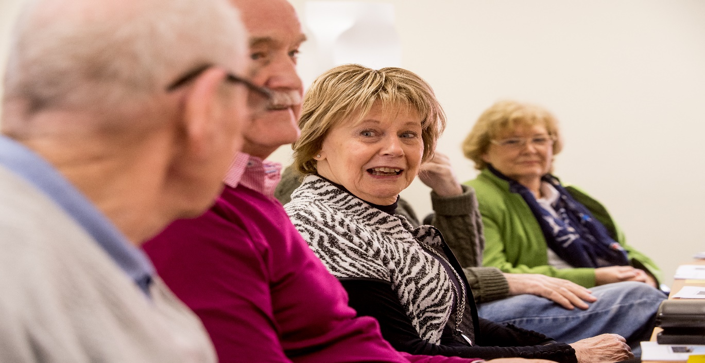

However, empowerment groups only work when people with dementia are motivated to join, so that the size of the group is sufficient to allow for group discussion and peer support.

Well the problem was that… I was the only member of this for a long time. I mean, (the facilitator) is great like, but there was nothing to bounce off anyone else (Member Interview – rural area)

The stigma surrounding dementia, that the organisation and members work so hard to battle, could actually create a barrier to people with dementia actually joining the empowerment groups, especially in rural areas where the illness was still very much a ‘taboo’ subject.

People are not coming forward because of the stigma (Member Interview)

There are unique recruitment challenges in rural areas… people don’t want to talk about dementia. They are very private and do not want communities knowing. (Staff Interview)

Furthermore, empowerment groups are more likely to achieve the desired outcomes when they are supported by experienced and effective facilitators. For example, group facilitators were held in high esteem, and had built-up trusting relationships with members, and as a result members felt motivated to take part, and enabled to see they were both worthy and capable of doing more than they thought they could post diagnosis.

Member talked about how without staff it (empowerment groups) wouldn’t work. Another member referred to the importance of the group facilitator sharing ideas “that we wouldn’t have thought of” (Observational data)

When I was diagnosed, I had lost all of my confidence. I realized I had more to give. Slowly but surely I built myself up again, through hard work and other people supporting me, the staff. We need people like that (facilitator) to help build up our confidence. (Member)

However, while empowerment groups ‘worked’ in terms of meeting some intended outcomes; namely improving quality of life of people with dementia, they were only able to fully achieve all intended outcomes through providing a platform for change.

It is important that we don’t go down the road of support groups. That is not what we are about… if we focus on safe space and emotional support then we risk diluting what the group is about… the emotional support is a benefit… but it’s an add on, it’s not the purpose” (Staff Interview)

It is giving people with dementia a voice… the media work has been very powerful. That didn’t really happen beforehand... the media I saw before was people sitting on the sofa with their carers sitting beside them talking. And the perception was very much that that is it. You are not involved in anything., you don’t have a voice…. But there wasn’t that focus on what you can do with dementia the positive side, the control people do and can have. That has changed now. That is massive… because the more there is a cultural shift and societal shift, that filters through to healthcare staff.” (Staff Interview)

Awareness raising activities
Observations, interviews and documentary analysis identified various awareness raising activities, which included improving understanding of dementia among communities, organisations and the general public. Members represented Dementia NI through public talks, training and education (e.g. health professionals and students), information stands and through the media (radio, TV, newspapers and social media). Awareness raising also included sharing advice on how to practically support a person living with dementia or encouraging people who think they may have dementia to contact their GP. Dementia NI provided resources to support members with dementia in awareness raising including branding, organisational skills (of staff), contacts, media training and transport to events.

Intended outcomes:
- Shape services
- Improve public awareness and understanding = reduced stigma/greater social inclusion

Awareness raising activities generated an ‘activist’ mentality among members, where they drew on their new found confidence, collective strength, and were motivated and driven to reduce the stigma surrounding dementia, along with highlighting the need for improving services. This helped increase members’ psychological wellbeing and created a sense of satisfaction that they were making a difference to the lives of other people with dementia, along with providing greater opportunities for civic contribution and political influence at local and national level. This required organisational and staff support in relation to providing resources and expertise for media training and other awareness raising activities. Consultation activities also created a key enabling context in relation to providing positive feedback on awareness raising activities.

All opinions, feedback and advice of Dementia NI members was acknowledged, used and incorporated into the campaign development process (‘I’m Still Me’ Media Campaign). One member of Dementia NI featured in print advertising as part of campaign. (Dementia NI Closing the Loop Feedback Form – Consultation with Public Health Agency)

However, interview data illustrated that the organisation provided more than simply training and resources, but also the psychological support to build members’ confidence to take part in awareness raising activities. For example, some members pointed out that they would not have been able to take part in a media campaign prior to joining an empowerment group.

And other people saying… you know ‘was that you on the tv’? Couldn’t have done that before… cause I’d be scared to do it. They (Group Facilitator) would help me, before I do anything and say to me now ‘you’ll be alright. I’m there to help you’. If you find you don’t want to do it, you don’t have to do it. (Member)

Members believed they had a “better chance of getting results if all people singing from the same hymnsheet … one voice very important” (Observation of Empowerment Group). Staff also viewed members of empowerment groups as having an activist mentality. “There is really a lot of speculation as to what we call our groups. I like to use the word activist. I want them (members) to feel as though they have changed the face of what dementia is, and they actually are doing that”. (Staff)

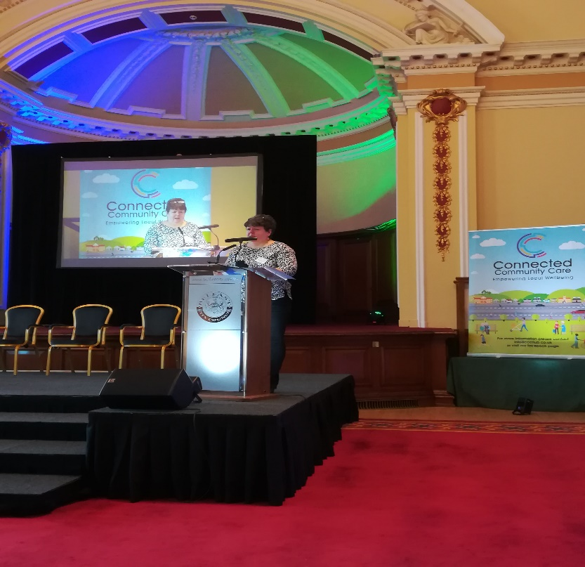

It was clear from the data that members wanted to challenge the stigma surrounding dementia, “Right from day one, I said I am going forward for this and I am going to… try and be an advocate… the whole thing is lifted, that whole façade of just people hiding in their homes” (Member Interview), and redress the power balance where people with dementia were seen as passive recipients, unable to advise or make decisions in relation to their own care “we should always be there at the decision making process, no matter where it is, across the board. We are capable of doing that and why we are not used at that level is beyond me. I’m always fighting to get involved at that decision making process because we are the people living with it… and have the most to give.” (Member)

Members alluded to improvements in their psychological wellbeing “it (talking at awareness raising event) was a real high” (Member), and their belief that they could make a real difference for other people with dementia not just at an individual level but at a wider community/societal level.

I’m going to make it better for the next guy coming along (Member Interview)
What would be a good result? –in a years’ time, or a year and a half’s time, we can all say it is better now than it was two years ago – better province wide. (Member Interview)

While Staff felt strongly that members were the driving force behind awareness raising activities “My work is really their (members) work…”, (Staff Interview) they also recognised that people with dementia do not necessarily have the opportunities to make a real change, and as such organisational capacity and support is crucial to raise awareness.

People with dementia do not necessarily have the opportunities. I am helping them to deliver on that (awareness raising) … having that (person with dementia) face in the media, having somebody with dementia on the radio talking about dementia… that’s really powerful for challenging and breaking down stigma. (Staff Interview)

While motivation was a key enabling context for people with dementia actually joining an empowerment group, positive feedback was also recognised as a key enabling context for maintaining that motivation among members. Without positive feedback, members could become demoralised and demotivated.

It’s important they (Members) are given as much feedback as possible on how they have influenced things – to see how they are making a difference. (Staff Interview)

Spoke about Chairman of health service – ‘they don’t want to know upstairs.’ (Member - Observation of Empowerment Group)

Consultation activities
Observation, interviews, and documentary analysis also identified the wide variety of consultation activities undertaken by members. Visiting organisations (for example Dementia Together NI, Queen’s Film Theatre, Radius Housing, and various public health charities such as NI Hospice, Action on Elder Abuse and Alzheimer’s Society) can request to attend empowerment group meetings or send materials for feedback. Members also bring their own initiatives to the group (e.g. Dementia Friendly Communities) or will approach organisations themselves.

Intended outcomes:
- Better inform policy-makers and service providers
- Increase involvement of People with dementia

Dementia NI provides a forum through which people with dementia can be consulted and involved in decisions affecting their care, services and communities. This gave members a voice and built their confidence to challenge those with decision making power to listen and act on the advice and guidance provided by those actually living with dementia. As a result, policy makers and service providers are better informed about the needs and aspirations of people with dementia. People with dementia are actively involved in policy and service development relative to dementia, leading to better support and services.

These outcomes are more likely to be generated in the context of empowerment groups, which help build members’ confidence to speak out on issues that affect them, and provide opportunities for consultation. Group facilitators advocated for members and protected against ‘tokenism’ by ensuring that any consultations with commissioners, practitioners, researchers and other user-led groups were followed through based on the advice and guidance provided by members. Intended outcomes are also more likely when there is a cultural shift within the health service and wider commissioning arena in relation to a greater sense of openness and interest in issues affecting people with dementia.

Evidence of members’ confidence to speak out, and have a say in how services affecting them are shaped, was captured during observations of an empowerment group. Members had a very impassioned discussion about an awards event they had attended for healthcare staff who had championed issues relevant to dementia. One member expressed his frustrations that some of those who won awards had not consulted with people with dementia. This member relayed how they had approached one of the winners at the event to raise awareness of the empowerment groups which led to the winner requesting a consultation with members.

She needs to learn. She needs to see that people like us exist. (Member)

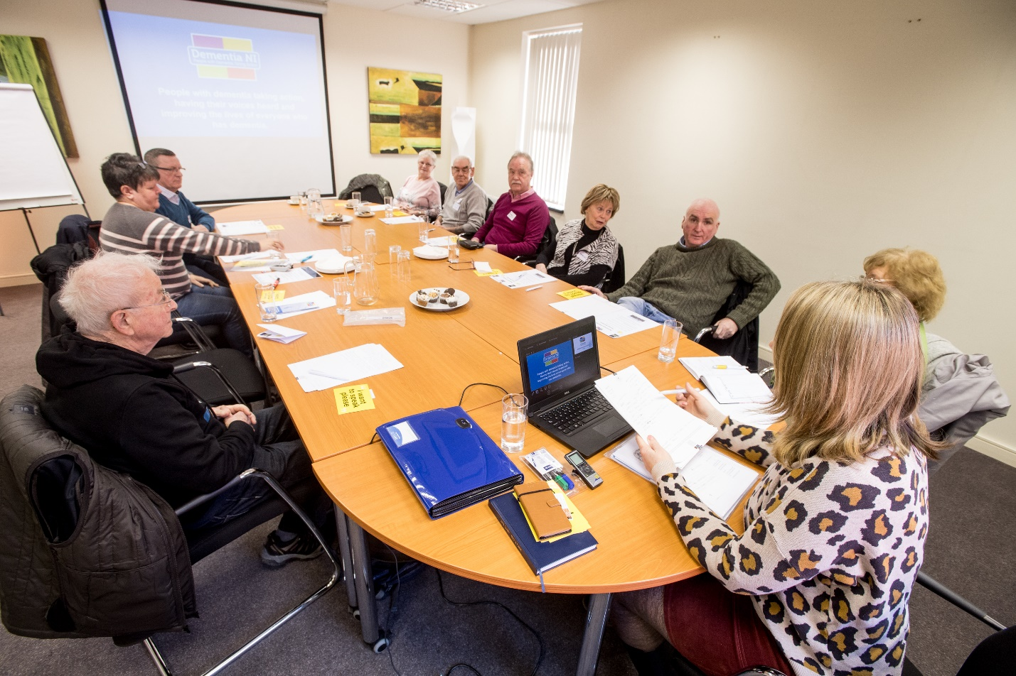

Policy makers and service providers are better informed about the needs and aspirations of people with dementia. People with dementia are actively involved in policy and service development relative to dementia, leading to better support and services. Evidence of how consultation activities led to improved support and services was also demonstrated in feedback from consultations with service providers.

We have fully included all feedback from the Dementia NI members in relation to improving ongoing engagement and recording of information that is pertinent to maximising the potential prevention and management of any diagnosis of delirium. The feedback from staff questions to Dementia NI members have been incorporated into the evaluation of the event for future reference. Engagement with the group enabled feedback in relation to language and images used to convey risks associated with delirium and how people with dementia and their family/carers can engage with healthcare staff to improve outcomes for those at risk or diagnosed with delirium. (Dementia NI Closing the Loop Feedback Form – Consultation with Public Health Agency in relation to a Delirium Launch Event to front line staff, management and other external stakeholders)

At the initial stages of the development of the Dementia Learning and Development Framework I had arranged monthly workshops. At our very first workshop, (Member) gave a very in-depth account of her experiences of availing of health and social care (both positive and negative) throughout the three years prior to her formal diagnosis of dementia and the period thereafter. Her (Member) contribution at this very early stage set the scene and outlined the key knowledge and skills required of health and social care staff in order for them to interact and respond sensitively to the needs of those living with a dementia and their families and carers. All requests and views from Dementia NI were accepted and incorporated into the development of the Framework. Their valuable participation and contribution recognised the importance of collaboration between the person living with dementia, their families and carers as well as health and social care staff throughout the person’s journey with dementia. (Dementia NI Closing the Loop Feedback Form – Consultation with Dementia Together NI)

Observation and interview data also demonstrated the importance of group facilitators for ensuring that consultation activities would bring about positive change for members, rather than simply benefiting external organisations.

Staff encourage, support and protect members - responsible for administration – people who want to come in and consult with members – filters those who are genuinely wanting the opinion of people with dementia versus tickbox exercise. (Observation of Empowerment Group)

“Do not come and use us for your own benefit then not give feedback on how we have helped you” (Staff Quote)

For example, group facilitators developed Closing the loop documentation to ensure consultations were followed through with actions. This documentation included a Visitor Request Form where those requesting a visit to the Empowerment Group had to outline their aims and expectations for a consultation. Visitors were also requested to fill in an agreement to return a ‘Closing the Loop Feedback Form’ within three months of their consultation, outlining how much they, or their organisation were able to implement based on the requests and opinions of members. The increasing openness and interest in issues affecting people with dementia was evidenced by the large volume of visitor requests for consultations from those in commissioning and healthcare services, along with wider community services, such as libraries and Film theatres.

Although we have separated these three core activities (empowerment groups, awareness raising and consultation), it is important to note that they are all interrelated. For example, empowerment groups are a key enabling context for awareness raising and consultation. Likewise, awareness raising and consultation are key enabling contexts for generating a sense of empowerment among members. Empowerment groups would be merely peer support groups if the organisation did not have awareness raising and consultation as key goals.

There are various ways people can take action within the group, whether that is taking part in a discussion group, a survey, if it’s indirect involvement, or very direct speaking to the media or part of a visible campaign, they are taking action to make some change and that’s what is really valuable for people. Because most of them feel the action they take now will not make immediate change, but they are part of something that might make a change… the drive to want to change. It is beyond support. (Staff Interview)

Likewise, awareness raising and consultation would be less likely if members did not feel empowered to have a voice, along with opportunities for adequate training and support.
Furthermore, although we have theorised about these core activities as distinct resources offered by the organisation, we cannot fully appreciate why, and how they work without due attention to the running of the organisation as a whole. For example, observations of Dementia NI board meetings, made up of a chairperson, a co-chairperson (member with dementia), a treasurer and two directors, provided no indication that the person with dementia was treated any differently to other members of the board. Decisions appeared to be made based on the consensus of all board members after thorough discussions. The person with dementia always referred to what do ‘we’ think, suggesting he felt very much involved, and put suggestions back to other members for feedback and vice versa.

The person with dementia demonstrated autonomy during the meeting, and was equally involved throughout. He was as able and comfortable to share his opinions as anyone else at the meeting. Although some members did dominate some discussions, this appeared to be more due to their personal experience in certain areas such as finance, grant bids etc. Similarly, people with dementia more likely to dominate discussions when of more direct relevance to issues around other people with dementia. So overall, was a good mix of skill sets with everyone contributing on important issues. (Observation of Dementia NI Board Meeting)

Furthermore, Board members were very keen to have more members involved. However, the board member with dementia recognised and pointed out that other members may not be able for, or interested in certain decision making activities.

A summary of the findings are presented in Table 2 and identify what works in terms of Dementia NI’s activities, and what circumstances help the organization meet its intended outcomes.

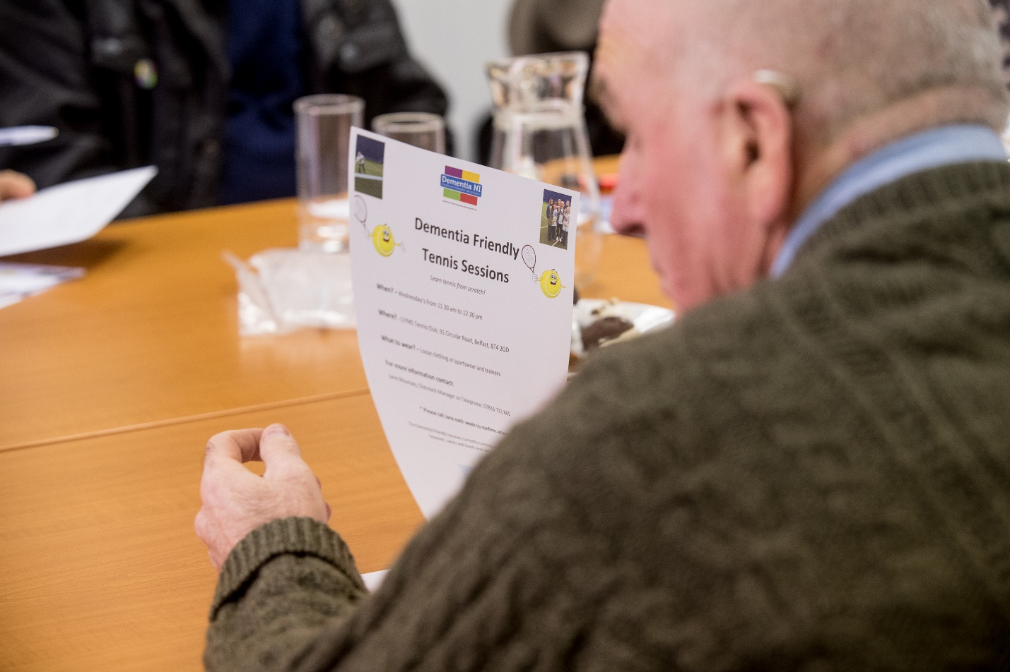
Table 2. What works, for whom, and in what circumstances?

In what circumstances?  What needs to be in place for Dementia NI to achieve their intended outcomes | What works, for whom?  What activities / resources help Dementia NI achieve their intended outcomes | Intended outcomes
Empowerment Groups
Enabling  - Experienced and effective facilitators  - Size of group is sufficient to allow for discussion and comparison | Opportunities in which people with dementia encouraged and facilitated to use existing skills and learn new skills  Safe space for peer support where people with dementia can share experiences and learn more about dementia  Trusting relationship between group facilitator and members so members motivated to take part | Improve quality of life for members  - Enhanced peer networks and social activity  Including observed outcomes that help explain how intervention leads to intended outcomes  - Increased confidence and self-esteem  - Kept members’ minds active.  - More openness around diagnosis of  - dementia  - Improved relationships with family and friends  - Reduced isolation
Disabling  - Stigma surrounding dementia, especially in rural areas where the illness still very much a ‘taboo’ subject | People with dementia reluctant to join empowerment group | Size of group not sufficient to allow for discussion and comparison
Awareness Raising Activities
Empowerment groups  Organisational and staff support  Resources and expertise for media training and other awareness raising activities  Positive feedback from consultation exercises | Organisation and group facilitators provided members with the tools required for raising public awareness and educating the public on dementia. This generated an ‘activist’ mentality among members, where they drew on their new found confidence, collective strength, and were motivated and driven to reduce the stigma surrounding dementia, along with highlighting the need for improving services. | Satisfaction from making a difference to the lives of people with dementia  Greater opportunity for civic contribution and political influence at local and national level  Improved public awareness and understanding of dementia resulting in reduced stigma and greater social inclusion of people with dementia
Consultation
Empowerment groups provide a forum through which people with dementia can be consulted and involved in decisions affecting their care, services and communities  Group facilitators advocate for members and protect against ‘tokenism.’  Cultural shift within the health service and wider commissioning arena in relation to a greater sense of openness and interest in issues affecting people with dementia | Enables members to have a voice, and builds their confidence to challenge those with decision making power to listen and act on the advice and guidance provided by those actually living with dementia | Better informed policy makers and service providers who recognise the needs and aspirations of people with dementia  Increased involvement of people with dementia as active co-producers of policy and service development  Better services and support for people with dementia

Discussion

Main findings
Findings demonstrate that Dementia NI work from an ethos of true member-led involvement and decision making, employed effective, empathetic facilitators to set up and manage empowerment groups for and with people with dementia, provided resources and expertise for media training and other awareness raising activities, and provided a forum through which people with dementia can be consulted and involved in decisions affecting their care, services and communities. This appears to lead to members feeling empowered and motivated to take on proactive, independent key roles within the organisation. Positive outcomes such as improved quality of life for members, improved public awareness and understanding of dementia, were reported. This may lead to reduced stigma and greater social inclusion, and increased involvement of people with dementia as active co-producers of policy and service development. The aim of which is better services and support for people with dementia.

However, as our findings highlight, context is key not only at an organisational level, but also on an individual level (the person with dementia is motivated to join an empowerment group), and wider HSC and policy level (real desire for change rather than tokenistic).

Contribution to the evidence base
Although there have been increasing steps taken to ensure that people with dementia have a voice in relation to key decisions affecting independent living, along with their treatment and care (Living Well with Dementia, 2009), there are still challenges and confusion around how to put these ideals into practice (Miller et al, 2014).

This evaluation used realist methods (Pawson, 2006) to help assess if Dementia NI were meeting their intended outcomes in relation to improving quality of life for members, better informing policy-makers and service providers, increasing involvement of people with dementia, shaping services, and improving public awareness and understanding, with the aim of reducing stigma. This evaluation has helped shed light on how the organisation’s various activities help generate intended outcomes, along with identifying what needs to be in place to help meet key organisational outcomes.

Findings are discussed further in relation to the critical social science literature on social power (French and Raven, 1959) which suggests that a shared social identity can create the possibility for attitudinal and political change, while also improving individuals own psychological wellbeing (Clare et al., 2008).

For example, findings indicated that membership of Dementia NI created a sense of collective strength that empowered people with dementia to overcome their previous sense of isolation, social marginalisation, and overcome the challenges to self and identity caused by a diagnosis of dementia.

Developing a shared social identity can lead to mutual support. This can result in group members assuming new roles and working together to create the changes they want to see in society. This in turn can lead to increased group identification and improved well-being for individual members (Reicher and Haslam, 2006b). We theorise that a shared social identity creates social power, creating motivation to generate the required resources, and enabling members to realise group and individual goals, resulting in political and attitudinal changes (Bruins, 1999; Turner, 2005, 2006).

However, whether awareness raising and consultations will have the desired effect in terms of reducing stigma, and improving services for people with dementia remains to be seen. However, having an activist mentality may have many benefits for members at an individual level in terms of feeling their lives have been enriched, and from a sense of empowerment. Although it is too soon to have any meaningful outcome measures in terms of measuring wider societal and/or cultural change, we can theorise that as the public are increasingly educated on dementia, this may eventually influence policy changes, which has been seen to happen in the past (Hobley, 2012).

Having effective group facilitators was found to be a key enabling context for Dementia NI empowerment groups. Although this is not a novel finding in relation to the importance of facilitation for successful implementation and sustainability of new interventions (McConnell et al., 2015), findings help provide important insights into what is the best style of facilitation (Clare et al., 2008). For example, while previous research suggests that professional facilitation is crucial for groups of people with dementia due to cognitive challenges (Jones, Cheston,& Gilliard,2002; LaBarge &Trtanj,1995;Yale,1995), group facilitation can unintentionally create dependence rather than independence. Our findings suggest that effective facilitation, in this context, effective in terms of enabling empowerment and independence of people with dementia, involves shared decision making, encouragement, and providing the necessary resources for people with dementia to use their many skills, and actualise their desire for involvement in key decision making processes that improve both their standing in society, and the health care that they receive.

For example, Dementia NI staff, including group facilitators were viewed as ‘working for members’. This helped demonstrate that empowerment of people with dementia was core to what Dementia NI wanted to achieve, rather than simply pay lip service to the concept of empowerment as has been seen in previous initiatives (Miller et al, 2014). Although staff facilitated core activities/interventions, these activities/interventions were driven by members’ passion about improving services and reducing the stigma surrounding dementia.

Service Improvements
In terms of areas for improvement, the organisation could benefit from establishing formal processes for capturing key outcomes at individual and wider community, service and policy level. For example, at an individual level, key outcomes could include measuring quality of life, and members’ sense of empowerment when members first join Dementia NI, and then again 6 months to one year later. At a wider community, service and policy level, key outcomes could include any impact on improving services and policy, evidence of reduced stigma and greater social inclusion. However, the latter two outcomes may involve capturing the steps taken to reduce stigma and create greater social inclusion, as these outcomes may be difficult to measure directly.

The organisation could also benefit from developing policies and procedures, involving members in discussions, on how to manage membership for those whose dementia has deteriorated.

Conclusion/lessons learned

These insights provide a new model for informing similar initiatives, which we urge others to test further in future research into empowering people with dementia. Within this model, we propose the following considerations for the successful implementation of empowerment initiatives for people with dementia.

- If people with dementia are provided with the opportunity to develop a shared social identity, this can create a sense of social power, generating motivation to access the required resources, and enabling members to realise group and individual goals, resulting in political and attitudinal changes

This is expanded on below in light of our findings. For example, there are a number of circumstances that make it more likely (or in some cases, less likely) that people with dementia will develop a shared social identity, and feel empowered to achieve positive outcomes at an individual, and wider political/societal level. These are outlined below.

- If group facilitators focus on encouraging members to recognise the many skills they have and can still learn, encourage shared decision making between members of the group in relation to improving services and support, provide opportunities for awareness raising and consultation with service providers and policy makers, then this is more likely to lead to improved quality of life for members, enhanced peer networks and social activity, increased confidence and self-esteem, maintenance of cognitive abilities, more openness around their diagnosis of dementia, and improved relationships with family and friends

- If the stigma surrounding dementia is not challenged, especially in rural areas where the illness is still very much a taboo subject, then expanding empowerment groups to rural areas is severely compromised as people with dementia will be more reluctant to join a group for fear of their diagnosis being exposed, preventing sufficient numbers for peer support, and collective action

- If there is organisational and staff support to set up empowerment groups, adequate resources and expertise for media training and awareness raising activities, and positive feedback from consultation exercises, then members will be enabled and empowered to educate the public on dementia, thereby challenging the stigma surrounding dementia, along with highlighting the need to improve services. As a result, members gain satisfaction from making a difference to the lives of people with dementia, have the opportunity for civic contribution and political influence at local and national level, and can work toward improving public awareness and understanding of dementia with the aim of reducing stigma and greater social inclusion of people with dementia

- If empowerment group facilitators generate opportunities for people with dementia to consult with policy makers, health care providers, and community services; and ensure consultations are followed up with actions based on members’ advice, this empowers people with dementia to have a voice, builds their confidence to challenge those with decision making power to listen and act on the advice and guidance provided by those actually living with dementia, resulting in better informed policy makers and service providers who recognise the needs and aspirations of people with dementia, increased involvement of people with dementia as active co-producers of policy and service development, and ultimately better services and support for people with dementia

- If there is a continuing cultural shift in the health service and wider commissioning arena in relation to a greater sense of openness and interest in issues affecting people with dementia, then they are more likely to take the advice of people with dementia on board and implement change in line with the needs of those actually living with dementia.

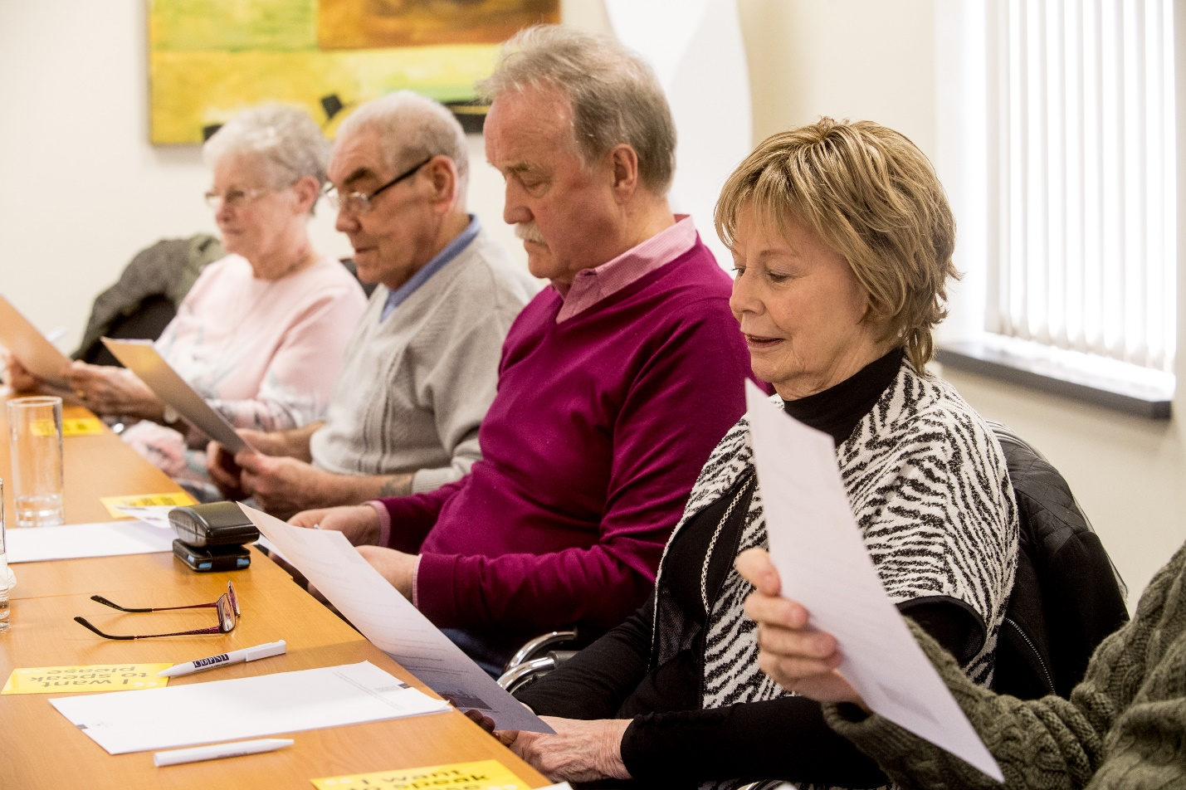

References

Bruins, J. (1999). Social power and influence tactics: A theoretical introduction. Journal of Social Issues,55, 7–14.

Clare, L., Rowland, J., & Quin, R. (2008). Collective strength: The impact of developing a shared social identity in early-stage dementia. Dementia, 7, 9-30.

Department of Health and Social Care (2009) Living Well with Dementia: a national dementia strategy. Accessed January 02 2018. Available at:
https://www.gov.uk/government/publications/living-well-with-dementia-a-national-dementia-strategy

Dewing J. (2007) Participatory research: a method for process consent with persons who have dementia. Dementia: the International Journal of Social Research and Practice .6(1): 11-25.

Donnelly J. (2004) Can adults with cognitive impairment consent to take part in research. Journal of Wound Care 13(7): 257-262. 38.

Emerson, R.M., Fretz, R.I & Shaw, L.L. (2011) Writing Ethnographic Fieldnotes. 2nd ed. Chicago, IL: University of Chicago Press.

French, J. R. P., & Raven, B. H. (1959). The bases of social power. In D. Cartwright (Ed.), Studies in social power (pp. 150–167)

Greenhalgh, T., Humphrey, C., Hughes, J., Macfarlane, F., Butler, C., Pawson, R. (2009) How do you modernize a health service? A realist evaluation of whole-scale transformation in London. Milbank Quarterly, 87(2):391-416.

Hobley M. Public opinion can play a positive role in policy making. The Guardian. 2012. Accessed January 02 2018. Available at: https://www.theguardian.com/public-leaders-network/2012/sep/03/public-opinion-influence-policy

Jones, K., Cheston, R., & Gilliard, J. (2002). Sharing problems through group psychotherapy. Journal of Dementia Care, 10(3), 26–27.

LaBarge, E., & Trtanj, F. (1995). A support group for people in the early stages of dementia of the Alzheimer’s type. Journal of Applied Gerontology, 14, 289–301

McConnell, T., O’Halloran, P., Donnelly, M. and Porter, S. Factors affecting the successful implementation and sustainability of the Liverpool Care Pathway for dying patients: a realist evaluation BMJ Supportive and Palliative Care, 2014, doi:10.1136/bmjspcare-2014-000723

Miller, L.M., Whitlatch, C.J., Lyons, S.L. (2014) Shared decision-making in dementia: A review of patient and family carer involvement. Dementia 15(5): 1141-1157

Pawson R. Evidence-based policy. A realist perspective. Sage, London 2006

Prince, M., Wimo, A., Guerchet, M., Ali, G.C., Wu, Y.T., Prina, M. (2015). World Alzheimer’s Report 2015, The Global Impact of Dementia: An analysis of prevalence, incidence, cost and trends. Alzheimer’s Disease International. Accessed January 02 2018. Available at: https://www.alz.co.uk/research/WorldAlzheimerReport2015.pdf

Reicher, S., & Haslam, S.A. (2006). Groups, psychological well-being and the health of societies. The Psychologist,19, 146–150.

Turner, J.C. (2005). Explaining the nature of power: A three-process theory. European Journal of Social Psychology,35, 1–22.

Turner, J.C. (2006). Tyranny, freedom and social structure: Escaping our theoretical prisons. British Journal of Social Psychology,45, 41–46.

Yale, R. (1995). Developing support groups for individuals with early stage Alzheimer’s disease: Planning, implementation and evaluation. Baltimore, MD: Health Professions Press.

Acknowledgments
We would like to express our heartfelt gratitude to both members and staff at Dementia NI for giving of their time to interviews, and for allowing us to observe the fantastic work they all do for empowering people with dementia.

