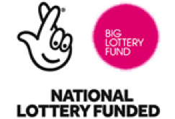
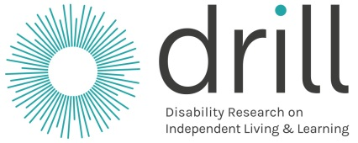

2nd Call
Questions and Answers

What is in this booklet?

 | Page
A General questions | 3
B What to do now | 8  11
C Research projects | 27  27  27  27  17
D Pilot projects

E UK and local projects | 20

Some questions and answers about DRILL

A. General questions

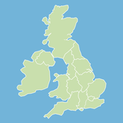
- How many projects will we give money to?

There will be about 40 projects across Northern Ireland. Wales, Scotland and England.

Last time we gave money to 21 projects. That was called the 1st Call stage.

This stage is called the 2nd Call.

There are lots of good projects.

But we can only give money to some of them.

- Who will decide who gets money?

Your form will be looked at by a group called a National Advisory Group.

There is a group like this for Scotland, Wales, Northern Ireland and England.

They will look at all the 2nd Call forms.

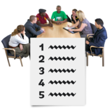

They will choose some projects that they think are good.

A group called The Central Research Committee will make the final decision about what projects to give money to.

They will do this in a fair way for everyone.

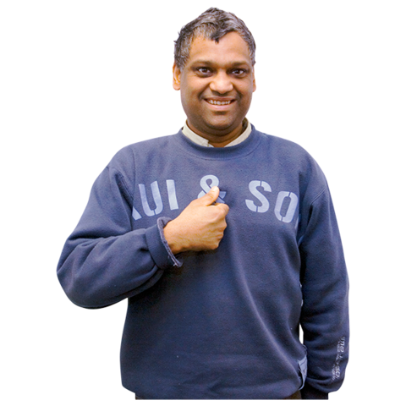
3. What do we mean by the main person to speak to?

There needs to be a main person for us to speak to about the project.

This person could be from any group you work with on the project.

This person will:
- be the person we speak to about DRILL
- be in charge of any money we give and send us reports when we ask them to

They should have experience of doing this work.

The organisation they work for must be good at looking after money in this way.
They must have enough money themselves.

The main person needs to send us some information about their organisation.

- Do you have to work with other organisations to do your project?

No you don’t.
But you must show us that:

- disabled people are a very big part of your project and make decisions about it

- disabled people and other people work together and have the same say in what happens

- the way you do your project is good and will work well

Often it is best to work with an organisation of disabled people to do this.

But we may give money to projects that work in different ways.

5. Can we give money to test important ideas?

We can do this sometimes.

We can give money to projects that test out a very good idea.

These projects are called pilot projects.

Sometimes people have already looked at this idea.

They have proved that it is a good idea.

The project will then test out this idea to see how it works in real life.

You can find out more about this in the About DRILL 2nd Call booklet.

There is information about the types of projects we will give money to from pages 10 to 12.

B. What to do now

6. How can you get an application form?

You need to fill in a 2nd Call application form.

Please fill in the form on the internet if possible.

Go to this website at:
http:/www.drill.flexigrant.com

7. Can you get information about DRILL in an easier way?

There is information on our website about how to ask DRILL for money in:
- easy read
- British Sign Language
- sound

The website is www.drilluk.org.uk

You can ask for information in Braille.

Please ask your DRILL Programme Officer for more information about this.

You can find out who this person is on pages 29 to 32 of the About DRILL 2nd Call booklet.

8. Can you apply for more than one project?
You can work with others on more than one DRILL project.

But if you are the main person to speak to you can only apply for one project at a time.

9. Do you still need to send in extra documents if a university will look after the project money?

Yes. You must send us the documents we ask for.

We need to check that we are happy with everything before we give a project money.

10. How about money for things like lights, electricity and stationery?

Things like lights, electricity and stationery are called Overheads.

You can spend money on these things for your project.

You can ask for all the money you will need for these things if they are:
- important for the project
- a good use of money

C. Research projects

11. How can you take part in DRILL as a researcher?

A researcher is someone who finds out information about something.

You do not need to be part of an organisation to do this.

But you need to find an organisation that can help you with:

- looking after the money for the project

- sending us reports when we ask for them

We cannot give money to people working on their own.

It is best if you work together with another organisation.

You can put an advert on the DRILL website to find people to work with you.

How to do this
Write something about:

- your project idea

- what area of the country you want to work in

- who you would like to work with

You can write 100 words or less.

Send it to your DRILL Programme Officer.

You can find out how to get in touch with them on pages 29 to 32 of the About DRILL 2nd Call booklet.

12. What if you don’t have a group of people who can check you are doing the project right?

All projects must have a group of people who can check that the project is OK.

This group of people is called an Ethics Committee.

The group checks things like:

- will the project cause any problems for people?
- will people be safe?

Universities and places that do research will have a group like this.

If you can’t find a group like this

Let us know. We have a group that you will have to use.

13. How can you find a research group to do your project with?

We cannot find a group for you.

But we can try to put people in touch with each other.

And we can give you some advice.

You can also ask your DRILL Programme Officer for information.

You can find out how to get in touch with them on pages 29 to 32 of the About DRILL 2nd Call booklet.

You can put an advert on the DRILL website about who you are looking for.

You need to send something to your DRILL Programme Officer.

There is information about how to do this in Question 11.
14. Who owns all the information and reports for the project?

Everyone in the project and DRILL will own this information.

That means everyone can use it in the way they need to. This should be free of charge.

There is a way of sharing information with people called Creative Commons.

It means people can see the information and use it if they need to.

We ask for everyone to share information using a way called Creative Commons Attribution Share-Alike 4.0 licence.

Your project may make programmes that work on a computer or mobile phone.
This is called software.

You should make sure other people can use it. You can use something called MIT, GPL or Apache to do this.
15. How should people in your project share information about it?

The people in your project may want to share information about it in special books or websites.

It is good if lots of people can see and use this information. It can help people learn more about your work.

People in your project can share information in lots of ways, like on websites and in books.

There is a website we want people to use to share information. It is called the UK Data Service:

https://www.ukdataservice.ac.uk

If the information is about people in your project you should make sure:

- you take out people’s names first before sharing the information

- you always ask people if they are OK for the information to be shared and used
D. Pilot projects

16. Can your pilot project have research in it as well?
Yes.

You need to apply as a pilot project.

The research you do must be part of the pilot project.

For example, checking how well the project has worked.

If you want to get information first to prove you should do the pilot project

You need to do 2 projects for this:

- a research project first

- then a pilot project

17. Should your pilot project have researchers or people from universities in it?

Researchers are people who look into something to find out more about it.

You don’t have to have someone like this in your project.

But you may want their help to see how the project will work.

For example, to see if the project will spend money in a good way.

Your pilot project will need to use good research and information.

18. What do you need to think about to apply for a pilot project?

You apply for a pilot project in the same way as a research project.

It will help to think about:

- how you will check how well the project works

- how the project will help with the things that DRILL wants to happen

You can find out more about this in the About DRILL 2nd Call booklet.

E. UK and local projects

19. Is it better to make your project about the whole of the UK or one country?

It does not matter.

20. What happens if your project is about something that happens across the whole country?

You apply for all projects in the same way.

We will look at where the main person to speak to is.

We will get the National Advisory Group in that country to look at your form.

21. Can we apply for 4 different projects in Northern Ireland, Wales, England and Scotland if our organisation works across the UK?

You can only do this if the parts of your organisation in each country manage themselves.

For example, if they make their own decisions and have a document called a Constitution.

You can ask your DRILL Programme Officer for more information about any of this.

Pictures by Photosymbols

