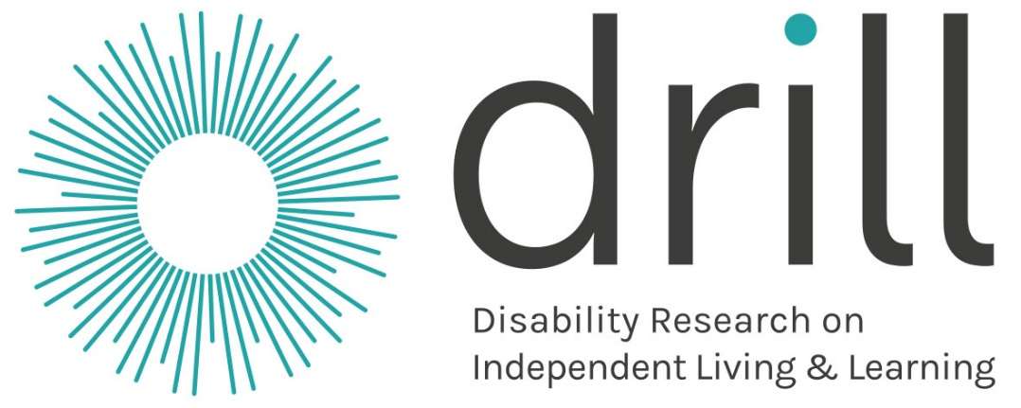

Roadshow Report for Scotland
March 2016

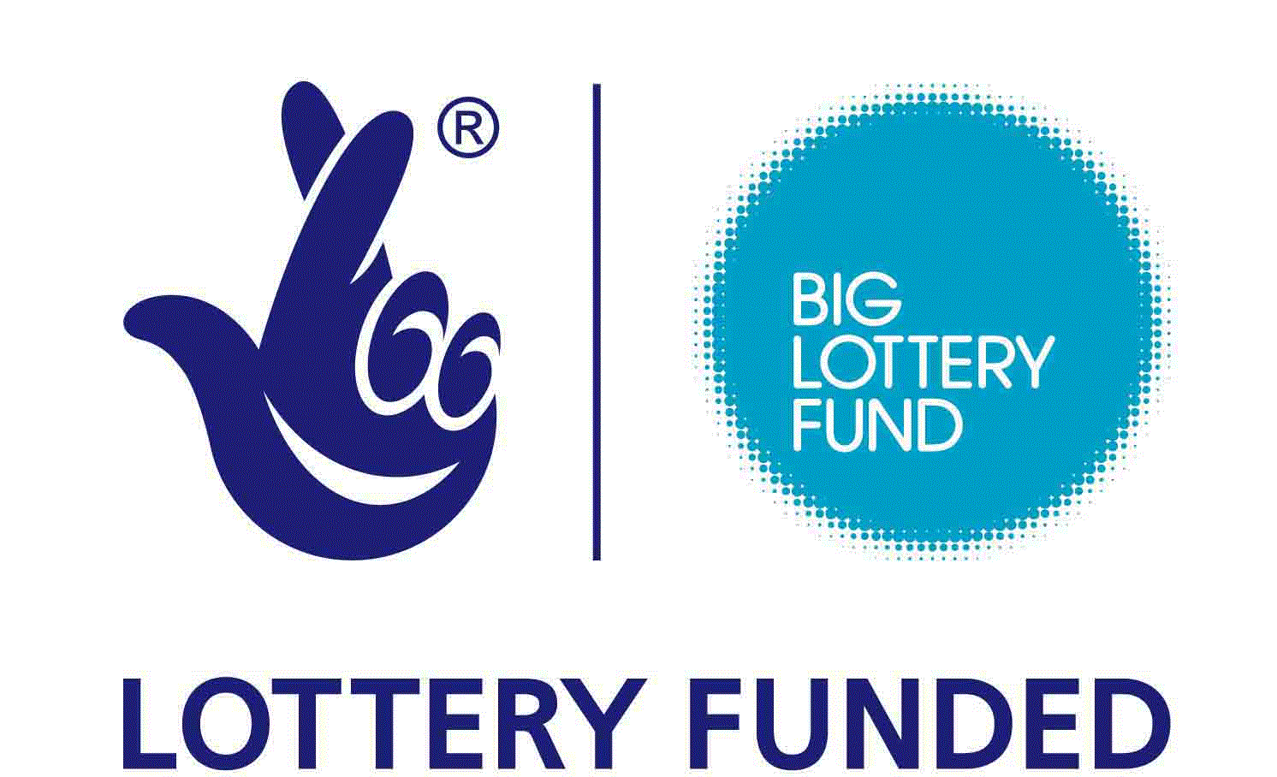
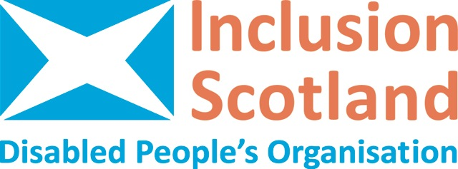
Contents Page

Page

2 Contents

3 Section 1: Executive Summary

4 Section 2: The National Context

4 Section 3: Partner Organisation Background

5-7 Section 4: The Roadshows

7 Section 5: Theme based feedback/critique
9 a) Priorities identified by the Roadshows
9 b) Economic Participation
12 c) Social Citizenship
15 d) Civic Participation
17 e) Cross-cutting
18 f) Critical feedback – new themes?
19 g) Challenges/ concerns voiced

21 Section 6: Summary of Amendments from the NAG

22 Section 7: Progression towards outcomes

24 Section 8: Details of participants

- Executive Summary

- Four Roadshows and a focus group were held across Scotland. Academic input came from a local speaker, on a range of research topics, at each of the Roadshows.

- Roundtable discussions held at the events generated valuable discussion on the themes that might be addressed with the DRILL funding. Participants were able to prioritise the areas most important to them and a breakdown is included in the full report. Highlights from the three key themes:

  - Under “economic participation” a popular solution was supporting disabled people to start their own businesses/social enterprises/ micro enterprises. In addition, a stronger understanding of the impact of acquired impairment and the support in place to enable people to remain in work was needed. The contribution of disabled volunteers should also be facilitated and valued more strongly.

  - Under “social citizenship” social connections and natural friendships were seen to be a key area for support and development. To enable this, issues like transport would need to be addressed. Catalysts for connections like community cafes and gardens were crucial.

  - Under “civic participation” participants strongly identified a need for a broad education and awareness project which would support all members of the public to understand the issues faced by disabled people. The public could learn about the social model of disability and relate this to their own life journeys and lived experiences.

- Peer support, peer education, peer champions and peer research were identified as crucial elements of the Programme, and had the potential for great impact.

- The NAG (Scotland) wanted to see values based approaches underpin the DRILL Programme. In particular, a Human Rights approach should be demonstrated in applications for funding.

- Scottish participants identified rural issues as being particularly important to address, as they often added barriers to participation.

- As Scotland gained further powers with more policy areas being devolved, it was important to consider where the DRILL research could inform and shape independent living for disabled people.

- Capacity Building was essential to the success of the Programme, at all levels, and for all of the partners involved.

- The NAG (Scotland) agreed that the existing themes need to be revisited and reworded to reflect an outcomes approach.

- The National Context – disability and policy

Scotland has had a devolved Parliament since 1999. The devolved administration already had powers over many policy areas important to disabled people and the achievement of independent living e.g. health, social care, housing, education and transport (partially devolved). Further additional powers over Disability (PIP, DLA, AA, Severe Disablement Allowance and Industrial Injuries Disablement Benefit) & Carers benefits and over Employability programmes such as the Work Programme and Work Choice will be devolved to Scotland along with their attendant budgets in 2017. There is therefore the potential to reshape the current Benefits and Employability regimes to make them more supportive of independent living.

- Partner Organisation Background

Inclusion Scotland is a national network of disabled people, their organisations and allies. Inclusion Scotland is run by disabled people themselves. Our mission is to ensure that policy affecting the everyday lives of disabled people in Scotland is informed by and reflects their views. We use the social model of disability in our work believing that people are not disabled because of a medical condition, but by barriers such as: negative attitudes; inaccessible buildings & transport; discrimination by employers; poverty; lack of information and power to make our voices heard. Inclusion Scotland works to promote Independent Living; meaning that disabled people should have the same freedom, choice, dignity and control over their lives as all other citizens. We inform disabled people about their human rights and take action to embed them into policy and practice. Inclusion Scotland promotes co-production which means working as equal partners, from the outset, in order to achieve an agreed outcome. We also work to make sure that decisions affecting disabled people’s daily lives are informed by their views and lived experience.

- The Roadshows

Following on from the launch of the DRILL project, which took place on the 22nd September 2015 at The Lighthouse, Glasgow, four Roadshow events were held.

Both the central belt events were fully booked. A good range of participants attended each Roadshow with a mix of disabled people, representatives from disabled people’s organisations, local third and public sector practitioners, representatives from national bodies and some academics. The time of year at which the roadshows were held affected attendance i.e. the Edinburgh event was impacted by heavy snowfall in surrounding areas and the closure of the Forth Road Bridge; Dumfries experienced severe floods in the run up to the event, and snow made travel to the Inverness event difficult for some. Another key piece of learning was that 6 weeks was insufficient time in which to prepare especially given the complexities of running events which catered effectively for all access, communication and dietary requirements.

Glasgow Roadshow: Monday 30/11/15
Recital Rooms, City Halls, Glasgow
44 participants

Edinburgh Roadshow: Friday 4/12/15
Norton Park Conference Centre, Edinburgh
32 participants

Dumfries Roadshow: Thursday 10/12/15
The Usual place, Dumfries
29 participants

Inverness Roadshow: Wednesday 16/12/15
Eden Court, Inverness
22 participants

A focus group also took place with 6 members of People First (Scotland) in January 2016. 133 people were engaged with in total.

At each of the Roadshows, participants were given the opportunity to ask questions about the DRILL Programme and have extensive roundtable discussions about the research themes, and in particular, where research might be able to address some of the barriers to independent living with solution-focussed pieces of work. Facilitators were organised in advance, and a total of 21 roundtable discussions were held. This enabled participants to feed back on their impressions of the themes, as well as to identify where their own areas of work might touch on some of the themes. Whilst participants were from a range of backgrounds, the emphasis was on how disabled people might be able to lead the research, and how new collaborations might enable this to happen effectively. The agenda was designed to allow people to make new connections and identify potential ways that they might be able to work in partnership. A networking lunch was provided at each event.

Delegate packs included DRILL Programme Information and slides of the research themes, and Easy Read agendas. Easy Read Programme Information and Research Theme print outs were also available. BSL interpreters, palantypists, audio loops and PAs were available at each of the events.

The three formal presentations provoked debate and discussion, as evidenced in the question and answer sessions. Josie Isles, Programme Officer, Inclusion Scotland, spoke in general terms on “An introduction to DRILL and the research themes” and Bill Scott, Director of Policy, Inclusion Scotland, spoke about “The Devolution of further powers” giving the Scottish context to the work that might take place over the next five years.

A local guest academic speaker attended each event bringing a different perspective on the research potential and methods through their presentations:

Glasgow – Professor Nick Watson “The purpose of research and the emancipatory research paradigm”

Edinburgh – Sarah Morton “Taking Research Partnerships Forward”

Dumfries – Dr Sandy Whitelaw “Evaluating complex interventions using “theory of change” approaches”

Inverness – Dr Kate Stephen “Research, participation in action research; design and delivery of research by service users”

All of these presentations will be made available via the DRILL website. In addition, the “Manifesto for Partnership Research between academic and other organisations” by Sarah Morton at The Centre for Research on Families and Relationships, University of Edinburgh, was used as a resource and can be found here: http://www.crfr.ac.uk/assets/manifesto.pdf

- Theme based feedback / critique

At all of the roadshows, participants had concerns about the themes. Current themes were focused on individual involvement rather than the structures in society that contribute to exclusion. Some felt that the focus of research should take a broader approach. Studies should look at how wider policy and institutions affect disabled people rather than the individual reactions and involvement of disabled people.
All categories were thought to be interlinked and interdependent, which made isolating issues under the headings problematic: e.g. “economic, social and civic participation all depend on social care and money”. The wording of the themes and the way they had been divided up provided considerable confusion at the start of the roundtable discussions, where dissection of the layout of the themes dominated, until the discussion was directed towards solution focussed research. As a starting point for discussion, the themes were not always helpful. Some of the language was off-putting and caused barriers to understanding, e.g. “civic participation”, “autonomy” required further definition.

The third row of boxes on the slides caused contention until we emphasised that this was not a definition of the theme, but an example, e.g., under “Economic Participation” the “Employment” category specified supporting young disabled people which seemed to exclude all other age group or those with learning disabilities. “Multiple Identities” was not seen as a “civic” theme but a “cross-cutting” one. Also highlighted was that welfare was a big part of economic participation that was not prominent in the themes. Much of people’s inability to participate economically is linked to welfare and care costs. Economic participation issues outside of career themes was missing, such as budgeting, and having money to spend on things like activities and consumer items. SDS was a highly discussed topic with concerns around uptake, client groups, access to SDS and barriers faced.

The themes also posed a danger of replicating silos everyone was working to break down. Generally, the categorisation of the research themes and ways they were being presented could be improved perhaps through simpler language and imagery. This was particularly highlighted by the People First (Scotland) focus group, who reported that many of the words were difficult to understand and could be simpler. It was felt that the themes needed to be more open questions, emphasising choice and control by disabled people, allowing people to identify gaps more effectively.

All the roadshows identified the need for a literature review, in order to capture the research that has been done to date. The gaps in literature reviews were important: Reshaping Care for Older People money had made great progress as part of Change Fund spending in identifying what worked, with the intention of scaling up solutions. However, issues like the importance of social connections were not supported in literature reviews when considering future spend for older people. Also raised was the need to share/pool evidence to avoid duplication, and to share existing good practice in the course of the DRILL Programme, in order to make the research as meaningful and useful as possible. Looking to examples beyond the UK was raised at every Roadshow e.g. Dumfries is twinned with Gifhorn in Germany which has led to reciprocal good practice approaches. Also emphasised was the role research might play in addressing the disconnect between theory – research - policy – legislation – practice.

- Priorities identified by the Roadshows

Participants were encouraged to identify their top priorities from the range of themes presented, using stickers:

Roadshow | Top broad theme | Top sub themes | Other important themes | Least important
Glasgow | Economic Participation | Education  Employment | Peer support,  New Service responses,  Multiple Identities  Inclusive Communities | None
Edinburgh | Social citizenship | Inclusive communities,  Public services  Volunteering | Active participation  Peer support  Multiple identities  Enabling leadership | None
Dumfries | Social citizenship | Inclusive communities,  Information | Employment,  Enabling Leadership,  Multiple Identities | Cross - cutting
Inverness | Social Citizenship | Inclusive Communities,  Public Services,  Volunteering | Employment,  Enabling Leadership,  Peer support  Peer support for Employment  Autonomy | Resilience

- Economic Participation
- The most discussed issue was the support needed for disabled people to start their own businesses/social enterprises/micro enterprises. What extra barriers are faced? More disabled people should be running their own organisations, or empowered to run services through the Community Empowerment (Scotland) Act 2015. Individual business planning support and networks of support for business start-ups were needed. Do disabled people have the support and knowledge they need to start social enterprises or know how to access support? In rural areas, micro enterprises were seen as a key solution to the future provision of services.
- Many employment systems for disabled people are based on the wrong assumptions: e.g. sometimes education is not necessary to do a job, but vocational training is. Evaluation of existing employability schemes is required i.e. are pre-employment courses for people with learning disabilities of any benefit? What do students gain? Are they cost effective? Do they consider individual aspirations? We need person centred, holistic employability support that’s differentiated depending on the impairment: e.g. the employment rate for people with learning disabilities/ difficulties is very low compared to disabled people in general. Supported employment and job coaches work as an approach, but are a postcode lottery. Employers also need support on career development for disabled people.
- Impact of acquired impairment: Can employers be supported with retention? Would research show this led to a fractured career path? Note that disabled people are worse off than their colleagues even if working, due to the costs of disability, making poverty a major issue. The expense of losing well trained and experienced staff due to impairment-related reasons or caring responsibility needs to be measured. Similarly, fluctuating conditions e.g. rheumatoid arthritis, mean people are only sometimes impaired: how is this handled in the workplace? Those with invisible impairments in particular need support in staying in work and participating.
- Misinformation could be passed from services like Social Work, DWP and Third Sector regarding services and entitlements: what guidance could serve to reduce mixed messages and confusion? Good information is crucial for getting back into work, for starting a first job, or for accessing benefits. Funding streams for access to Education and Work are currently a maze. What kind of impact is this having for disabled people and learning/employment organisations?
- Disability Equality Training (DET) and other training is needed for managers and staff to understand how to deal with their own conscious and unconscious bias. Can we research the difference DET makes? DET is gathering dust on shelves in schools too. Can we research what will bring the issues to life in schools, celebrate diversity and encourage a human rights approach?
- Access to Work (AtW): Could a volunteering access fund make a difference? Volunteers need support to participate too. AtW underspend was significant in Scotland. Could research take place around take up/issues? The labour market needs to be fit for disabled people and the needs of employers also need to be looked at. How can small employers support disabled people or find out about available support? There needs to be incentives for employers, or better branding for being a good employer. Can we promote inclusive policies better?
- Transitions are not just from child to adult services, and come up at different stages of life: How many people with long term conditions are supported in transitioning to either alternative types of work/ benefits? Comparative studies would be helpful, showing disabled young people at points of transition and comparing different settings (SEN, mainstream) with comparisons of outcomes with and without targeted interventions.
- Impact of policy e.g. Children and Young People (Scotland) Act 2014 – is this leading to longer term impact for disabled children and young people? Who is using or supporting people to use the Community Empowerment (Scotland) Act 2015? Can we assess the impact of emerging policy and legislation on disabled people?
- Look to international examples of good practice: e.g. Nordic Women’s Employability programme. Could people with sight loss/pan disability approaches use the same model to develop their business? Can we identify a comparative country in terms of size and rural/urban spread, infrastructure?
- Lifelong learning and education: Adult Community Learning and Development needs to be prioritised to support adult returners and over 25s into education and employment.
- Why is there an underspend on benefits? What are the underlying causes for this? Is the attitude of the DWP staff towards claimants a factor?
- Are there differences between third, public and private sectors in terms of the numbers of disabled people they employ?
- Social Citizenship

- Social Isolation – was this area specific in Scotland? Rural areas did seem to be more affected: isolation was a huge issue and strongly linked to costs, equipment and transport. It didn’t fit into any one policy area but its importance was becoming paramount given welfare reforms and cuts in care packages. Much more emphasis was needed on social connections in the research themes, and approaches to building these. The People First (Scotland) focus group saw building natural friendships as a top priority. Also, more research was needed on the role of the family as a support network, and the ability of disabled people to have an active role within the family. Can older people research other people’s responses to them?

- Art should be seen as an important tool for research – e.g., for people with communication difficulties. Some people have to rely on carers to tell their story. Forum Theatre was also seen as a useful tool to illustrate issues. Arts were seen as a crucial part of life, with work by Dementia Theatre and Birds of Paradise highlighted. Participation is therapeutic. Is an accessible events toolkit for events needed?

- Community Cafes and gardening were seen as natural catalysts for support, as were social enterprise initiatives. Natural support for transitions evolved through social contact. Fitness was a similar area with some interesting initiatives. Community hubs: how can these be used and promoted for community use? How can the approaches of communities that are already inclusive be learned from and replicated in other communities?
- Transport was a major issue in Dumfries and Inverness, where participants were clear that solutions were needed for rural transport to allow participation to even begin in many cases. Sometimes the smallest distances could prove difficult. Parking spaces needed assessment, with those for children taking higher priority than those for disabled people. Costs were high, vehicles often inaccessible and spaces limited on public transport. A direct link was seen between rurality, disability and poverty. Equipment and transport was often funded by small charities with insecure funding. Mobility access issues were particularly important for young disabled people when accessing college, as support was not there past school leaving age.

- Accessibility: enforcing and developing the law around the accessibility of buildings, public and private, provision of accessible toilets etc. Similar to “dementia friendly” design – can we develop models, e.g., what does accessible housing mean to people who have learning difficulties? Need to research the difference in needs for people with sensory, cognitive impairments as well as physical. Housing doesn’t look at “reasonable adjustments”. Adaptations meet provider specification, not individual need. There’s very little research about what are best options to support living independently for autism. Access to facilities like IKEA/ supermarkets still poor. Perhaps the disabled pound (like the pink pound) needs to be promoted. Entertainment was often inaccessible, e.g., no lifts in cinemas, no ramps.
- Lack of suitable accommodation: can we create a national database of suitable accessible/adapted housing/ planning/ facilities? The wastage of changing adaptations repeatedly: can’t we leave houses empty for a bit rather than ripping out and re letting? What would the cost implications be?
- Service Provision: Can we address the inconsistency between “caring” organisations, i.e. different types of service providers? Cultures of different agencies can lead to dependency. Investigation of how to overcome this could help. In the design and development of public services we’re being treated as recipients of care packages, not citizens. The methods and attitudes of engagement by Health and Social Care agencies need to change. It’s important that services are not defensive, and instead ask “how can we work together to build trust?” How do social care models impact on quality of life and human rights? Involvement in the planning of services needed to happen far more effectively. We see good projects in the third sector but how can they be valued in public sector language?

- Accessibility and the tourist industry –Luxury accommodation is rarely adapted for disabled people. Some hotels have limited disabled access.
- Design – bringing designers, architects, and disabled people together through joint learning and working, and training of students. Could planners and decision makers have a better understanding of how they might be discriminating against disabled people, directly and indirectly?
- Working effectively with local access panels. Often these were firefighting and not an intrinsic part of design. Awareness raising of the panels is needed. “We need to change the mind-set of a nation and have a cradle to grave policy for everyone!”

- Personal Assistants: some people were uncomfortable with certain aspects of the current personal assistant system. ( low pay; work not respected; quality of life of people who use them; the effects that having a PA can have on independent living; should there be a register for PAs?)
- Use of technology – where does this work in terms of social participation? Can it be scaled up? Is technology what we’re really talking about under New Service Responses? Concerns around being unable to access aids were strong – especially more expensive and technologically advanced aids and adaptations.
- How do we involve people at the design stage of every service, developing and implementing coproduction? How do we define consultation, involvement, participation, engagement etc. in this context?

- Impact on the individual of caring responsibilities – especially women – can we research where disabled people are informal carers?

- Civic Participation

- Identity: A need for group action and group awareness of all disabled people, to include definitions of disability, and human rights. Broader education needs to take place in schools, the workplace and at all stages of life. People also need to be enabled to educate themselves, perhaps through placements in disabled people’s organisations. A national awakening is required. Can we use existing research around social attitudes to disabled people? What can we learn from other work going on to change attitudes (See Me – mental health; Life Changes Trust- dementia; anti-sectarianism?). How do we embed the Social Model in people’s minds? Independent living is executed under the banner of care, not as a broader principle, as it should be. Hate Crime could be reduced dramatically through a broader public awareness campaign of this type.

- Value: civic participation shouldn’t be dependent on employment or education. All people should be valued and able to participate. People have value as citizens and as people. There is too much pressure on people to be economically active whereas social and civic action should be just as important. A human rights approach is crucial. We need to see the whole person, not just the disability or the financial contribution. We need “recognition of the skills and attributes that disabled people have and the contribution they make to society”

- Hidden/ Invisible impairments– awareness raising particularly needed here, around how assumptions create barriers. Similarly, multiple impairments need to be looked at more closely in terms of the way bodies like the NHS work with a patient across their departments. NHS “categorisation” is unhelpful. We need crossover research so that the Health and Social Care Integration agenda will work. How can we focus on the shared experience of barriers to inclusion rather than the individual’s impairment?
- Access to Law, and understanding of human rights – disabled people need access to information and support. Can we illustrate the link between human rights and citizenship?

- Fear underpins participation at present – fear of sanctions, recriminations. This should be replaced with trust.

- Disclosure – fear of recrimination can prevent people from disclosing their needs – leading to discrimination. How do we interact with people who don’t disclose impairments or don’t know how the language/ legislation around disability applies to them (not diagnosed/ don’t link long term conditions with disability)?
- Leadership was possible in a movement of DPOs – a strengthening of shared identities. Collective advocacy was needed to do this.

- Groups were looking at current barriers to political participation. The 1 in 5 project has helped, but we need a systemic approach to systemic problems. We need more elected representatives and powers to implement the disability discrimination laws. The right to vote is important.

- Equality Impact Assessments: How can disabled people work with Government and other public bodies to do better Equality Impact Assessments?

- Community Planning – how does this fit in?

- Could research scholarships be part of the DRILL Programme?

- Cross – cutting

Autonomy
- We need to challenge the structural barriers that provide challenges to autonomy.
Peer Support
- Peer counselling, peer research, peer education – many distinct approaches to working with peers. We need to define what is meant by these terms and include them all as part of the DRILL programme.
- Within the term “peer support” there are different models, e.g., peer support groups, Support can be intentional or non-intentional, voluntary or paid. What can we learn from the Peer Learning Network for Scotland and other networks looking at peer issues?
- Pan – impairment support is needed to develop dialogue around capability, i.e. the focus on what individuals are able to do (capable of).
- Particularly valuable for disabled employees: how can peer support work well at work? How can it be rolled out? Success stories of disabled people in employment/ case studies of barrier removal techniques?
- Works very well especially in mental health and for autism/ Asperger’s. Well evidenced but undervalued at present.
- Peer champions: promotion of role models. Self-identification is important. Social media has a role to play.
Resilience
- There was a general discomfort with the term “resilience”: the term implied that the onus was on the disabled person to deal with the discrimination in society and the associated issues, rather than making society more inclusive, and likened to the medical model. Some people suggested alternatives like “inner strength or inner growth” which illustrated how misunderstood this term could be.
- Resilience in this context really has nothing to do with individual disabled people’s “inner strength or growth”. That would be shifting the blame onto disabled people for failing to be “resilient” enough to cope with, e.g. benefit cuts. Resilience is instead more about building disabled people’s collective capacity, alongside allies, etc., to come up with solutions/withstand attacks on their benefits, services, etc. The problems need to be fixed top down, not by the individual. “Should the issue really be how can disabled people be resilient to a system we don’t like? Shouldn’t this be “resistance”?”

Concerns were also raised around the concept of empowerment. The disability industry keeps people disabled. “Enablement is more like making sure I can take part using the rights I have.”

- Critical feedback – new themes?

In addition to the introductory comments on the existing themes:

- Rural issues particularly important in Scotland. Solutions that work in Glasgow may not necessarily work in the Highlands, e.g. can’t get care workers in some areas. The Scottish environment, climate and culture potentially affects disabled people differently.
- Social Connections given strong emphasis. An alternative theme suggestion was “public attitudes” which would include things like hate crime, relationships, parenting and family life.
- “Rights” was also seen as a key theme, missing from the existing selection. At all of the sessions, human rights and how they related to disabled people were referenced regularly. It was suggested that a rights focus might replace the social citizenship strand.
- In mental health, we speak about having the four assets to combat oppression: social, financial, physical and emotional assets. Is this not a better thematic approach? It’s about having the trust in your capability, not what you’re told you’re capable of.
- Self-management is crucial to sustained resilience. Should this feature more highly in the themes?
- Transition was thought to be not just something talked about with 16-18 year olds, but constant, for all of us. We need a much heavier emphasis on adult transition, and life journeys.
- Lifelong Learning: Ongoing education for all.
- Greater emphasis on health and wellbeing.
- Capacity Building: underpinned much of the above.

- Challenges / concerns voiced

- Capacity Building: Could smaller orgs be overlooked by DRILL? Larger orgs may have more clout/capacity to successfully write the bid and have wider access to participants for research, but smaller orgs/individuals could have just as good if not better research ideas. There were concerns around the need for money to be managed by an organisation and how reputation might help DRILL know money would be used effectively. Capacity building needed with organisations to ensure participation. Support needed to build partnership working so that research is interlinked e.g. between volunteering projects and public services.

- Language –the need for common, simple, inclusive jargon free language which crosses all sectors. Often disabled people become professional volunteers sharing lived experience for free: something to avoid. Even then, it’s because they are able to speak the language that they are consulted and engaged with.

- Devolution and how it may make services better. How would benefits look after devolution of further powers? The effects of impending poverty as detailed in Bill’s presentation and policy like austerity raised concerns. Implications of policy change: much talk around Self Directed Support and Health and Social Care Integration.
- Reaching those hardest to reach. How do we include people with severe learning difficulties? What about those with multiple barriers? Need to build in time to reach the people who are seldom heard or easily ignored. There is a lack of opportunity for people with complex needs.

- How do we include BME and older people? Language and education were barriers here: there was no word for disability in Punjabi, for example. Some cultures just talk about being ill, following a medical model. Could Independent Living Champions address this?
- Research must have tangible outcomes, and not be based on numbers. Concerns were raised that qualitative approaches would not be valued. Lived experience was the most important type of evidence and could lead to culture change and leaps forward in self-management.

- How can we ensure that research is inclusive of a range of impairments and truly pan-impairment? Single impairment organisations – could they work together more effectively? This was thought to be the role of The Alliance. Could the numbers of people with different types and degrees of impairments be more widely understood, especially in terms of how this relates to spend on areas of care related to each one?

- Partnership means a social commitment not just a financial commitment. Time needed to build trust with employers, education services, academics, and disabled people - across the board. Time is also needed to build links with families and carers of disabled people. All these groups may need to be included in research.

- Multiple hats – many people involved in the research will have multiple roles in their lives as disabled people/ practitioners for disabled people/ professionals/ carers for disabled people. It’s often hard to give people distinct categories. (3 in 5 people will be carers at some point. 1 in 4 will have a mental health condition. 1 in 3 will have dementia.)

- The research should be advertised with Local Authorities and Housing Associations to try and reach more than “the usual suspects” (DPOs and third sector organisations), and to build their skills in developing services led by disabled people. However, there would need to be an emphasis on the bids being led by disabled people.

- Summary of amendments coming forward from the Scottish Roadshows for DRILL, as considered at the first meeting of the Scottish NAG on 12th January 2016.

- The way that the themes are currently presented creates barriers. The NAG member using a screen reader was unable to read them. They create silos, and artificial boundaries between themes: too prescriptive. The NAG agreed that they needed to be changed and simplified.

- The language used should be more accessible, linking with outcomes language people are familiar with. The themes should be presented as outcome measures for the fund.

- Suggested alternatives were
- The Resilience Matrix (see Scottish Government website)
- The SHANARRI Indicators/ Wellbeing Wheel (see Scottish Government website)
- Originating from disabled people themselves, the five categories from Glasgow Disability Alliance’s recent report “Promoting wellbeing through the integration of health and social care in Glasgow: the views and priorities of disabled people”, around Wellbeing, Connectedness, Participation, Contribution and Financial Inclusion.

- The emphasis given to particular areas within the themes (Section 5) does not reflect the wider views of disabled people accurately, and should not be used to prioritise funding. The findings were affected by the way the themes were laid out, the emphasis given to a solution focus and the examples included on the theme slides.

- The outcome measures used to define the criteria for the research funding should be broad, with no prior identification of specific issues to be addressed. They should leave space for disabled people to identify gaps, and not be limiting or restrictive.

- Underpinning research and outcome measures should be a values based approach, particularly:
- A capabilities approach with a focus on what individuals are able to do (capable of).
- A Human Rights based approach, emphasising the PANEL principles of Participation, Accountability, Non-discrimination and equality, Empowerment and Legality, or the FREDA values developed by the learning disability community (Fairness, Respect, Equality, Dignity, Autonomy).

- The “outcomes” given in Section 7 should link to these new broader fund outcomes. The wording of the existing “outcomes” should be revisited and coproduced.

- The emphasis should be on what we want to change, not what we want to research. The new research outcomes should create an umbrella welcoming a range of bids to encourage the greatest impact with a small amount of money.

- Progression towards measuring outcomes:

Outcome 1
Disabled people have increased knowledge about key issues and new evidence of what works, enabling them to achieve independent living and fulfil their potential
INDICATOR | INDICATOR LEVEL | ACTIVITY | Timeframe
The proportion of disabled people who feel they are more knowledgeable about key issues and evidence of what works to assist independent living | 85% of disabled people engaged feel they have increased knowledge of key issues and understanding of approaches to independent living | Road shows and ongoing engagement through DRPOs at a national level | By the end of Year 1

On a 1-10 scale pre and post event | Glasgow | Edinburgh | Dumfries | Inverness
- | - | II | - | -
Same | IIIIIII | II | IIII | II
+1 | IIIIIII | II | IIIII | I
+2 | IIIII | IIIIIIIIIII | IIIII | III
+3 | IIII | I | II | II
+more | - | - | II | IIII
Most frequent start | 7 | 6,7,8 | 7,8,9 | 5
Most frequent end | 8 | 7,8,9 | 8,9,10 | 8

76% of participants increased their knowledge about independent living and learning. 20% stayed the same.

On a 1-10 scale pre and post event | Glasgow | Edinburgh | Dumfries | Inverness
- | I | - | - | -
Same | IIIII | III | II | I
+1 | IIIIII | IIIIII | II | IIII
+2 | IIIIII | IIII | IIIII | II
+3 | III | - | IIIII | I
+more | II | III | IIII | IIIII
Most frequent start | 6,7,9 | 5,6 | 1,4,7 | 1,6
Most frequent end | 7,8,9 | 8,9 | 7,8,9 | 7,8

83% of participants increased their knowledge of disability research. 15% stayed the same.

Outcome 4
Disabled people are empowered and have directly influenced decisions about services that affect them
INDICATOR | INDICATOR LEVEL | ACTIVITY | Timeframe
The number of disabled people that have directly contributed to the project through the dedicated website, promotional activities and roadshow events | 10,000 disabled people have contributed to the project | All DRILL activities | By the end of Year 3

NB Monitoring below counted 27 people as being disabled, but our attendance lists indicated that at least double this number actually attended: 54. The Monitoring forms were only completed by half of those attending.

- Details of Participants

- Evaluations (76 received)
- Keep in Touch Forms (67 received)
- Equality and Diversity Monitoring Forms (62 received)
- Inclusion Scotland membership forms, optional (15 received)

Completed Equality and Diversity Forms gave these details about participants:
- 61% were women
- 82% were heterosexual
- 44% were disabled. Disabled people formed a majority at two events.
- Physical disabilities were the most highly represented, followed by long-term conditions then multiple disabilities
- Dyspraxia was mentioned twice as a disability definition not listed.
- 97% were White
- 52% were Christian, and there was no category for Latter Day Saints.
- 29% were carers

However, the design of the form and the categorisations on it were found to be off-putting, and commented on by several people. They preferred not to identify in the ways listed, including age and ethnic group, and refused to complete sections, if they agreed to use the form at all. The analysis was not always clear as a result, and for the disability section, many people identified with several of the categories. Recommendations would be to design the form to ask people about where they found barriers, and about where they had lived experience, with emphasis on the social model. These forms should not be about forcing identity, but about identifying where impairments interact with barriers, causing disability. The data would be far more meaningful and useful this way.

