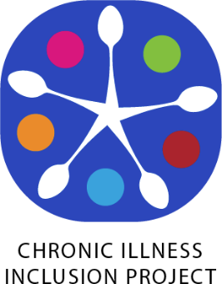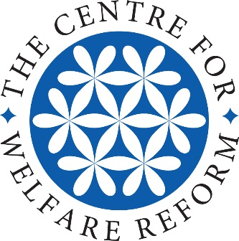

Energy impairment and disability inclusion:
Towards an advocacy movement for energy limiting chronic illness

By Catherine Hale, Stef Benstead, Jenny Lyus, Evan Odell, and Anna Ruddock.

Simplified Version
Produced with support from Sarah Hatch

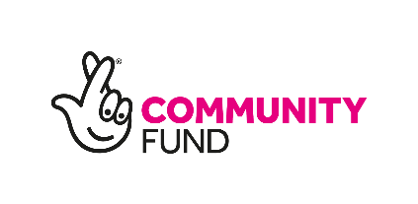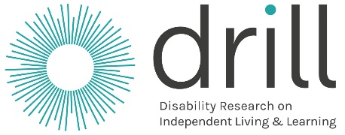

What is the Chronic Illness Inclusion Project?
The Chronic Illness Inclusion Project asked disabled people who live with chronic illness to tell us about their lives.
We did this with support from a programme called DRILL. DRILL believes that disabled people should be the ones who find out what would make their lives better, by doing research.
The researchers in our project live with chronic illness themselves. We think we have important knowledge and experiences to share with people who make decisions about our lives. We want them to see us, and to hear our voice.
We were inspired by other groups of disabled people who have come together to fight for the right to lead equal lives, the same as others. We want people with chronic illness to lead equal lives too, and to be respected.

What did the project do?
More than 2,000 people took part.
Some people took part in a focus group. This was a small discussion group that happened through the internet for eight weeks.
Other people answered our questions on the internet. This is called a survey.
We were interested in an idea called the social model of disability. The social model has helped disabled people to be treated the same as others, and be able to take part and join in with society. We asked if the social model could work for us too.
Our participants had many different kinds of illness. They really wanted to tell us what their life was like because they said no one understands. Lots of people said the same thing. The most common things were:

About my illness
The worst things about my illness are pain and fatigue.
Fatigue is not the same as feeling tired.
Fatigue has changed my whole life.
It means I can’t walk far, or I can’t walk at all.
It affects my brain and stops me thinking and speaking. It makes my whole body shut down and stop working.
I’m often stuck at home because my energy runs out too quickly if I go out and do anything.
I have to think very carefully about how I use my energy to make sure I have enough to get through the day.
Even small things like getting dressed use up lots of my energy. This makes my life very different from other people’s, who can take their energy for granted because it hardly ever runs out.

What other people think
People can’t see that I need support.
People think I should just try harder.
People think I’m lazy.
People think I’m pretending.

How this affects me
These things hurt me and make me feel bad about myself.
They make me feel like I don’t deserve help and shouldn’t ask for it.
People not understanding makes me feel lonely.
Being stuck at home instead of out working or meeting my friends makes me lonely.
It stops me doing things. I worry about people judging me and telling the government that I’m not really disabled and I’m a cheat.
I try to be like everyone else but this makes my illness worse.
It’s too difficult to ask for help because often people don’t believe that I’m a disabled person so they think they don’t need to help me.
When I find the strength to challenge these harmful messages, I feel better. When I find the confidence to say I am disabled and I need help and support, even when other people don’t believe me, I can have a better life.

The social model of disability
People agreed with some parts of the social model of disability. They agreed that:
- Harmful messages stop us from feeling accepted and loved and stop us from getting help to do things that could make our life bigger and better.
- It helps us to realise that these harmful messages come from other people, not ourselves.
- These messages affect other people with chronic illness.
- If we join together we can be stronger in saying No to the harmful messages.

People disagreed with some parts of the social model. The social model says that the problem is not with our bodies, it is with how people treat us. People said that:
- Disability is definitely inside their body and they wished it could be fixed.
- They wanted to be healthier and they think medicine and medical treatment is the best way to do this.

They still believe that they could have better lives if people in power listened to us. They said the two biggest problems are:
- Doctors and the health system
- The benefit system

Talking about fatigue
People said that when they use the word ‘fatigue’ people think it is the same as being tired. People don’t understand how fatigue affects them or they don’t believe them.
People thought ‘energy impairment’ was a better way to describe it. They liked the word ‘impairment’ because all disabled people can use it.
They also liked the phrase ‘energy limiting chronic illness’.

What next?
We think that the people in charge of our lives should listen to us.
They should think about energy limiting chronic illness and energy impairment when they make plans and decisions that affect us, such as deciding who can get money to live on because they are disabled.
We also want other groups of disabled people to listen to us and include us, and to use our words when they talk about us. We want everybody to listen to us, believe us, and accept us for who we are.
Everyone said they wanted to carry on thinking and talking and getting organised with fighting for a better life as a disabled person with energy limiting chronic illness.

This document is a simplified version of the report: Energy Impairment and Disability Inclusion.

Publishing Information for the Report:

Energy Impairment and Disability Inclusion © Catherine Hale, Stef Benstead, Jenny Lyus, Evan Odell and Anna Ruddock 2020
Figures © Evan Odell 2020
First published April 2020
Energy Impairment and Disability Inclusion is published by the Centre for Welfare Reform.
If you copy and reuse any part of the material in the report then you must always cite both the author and the publisher and, wherever possible, provide a direct link to the Centre for Welfare Reform's website.
www.centreforwelfarereform.org
Adapted from an original design by Henry Iles.
90 pp
ISBN download:978-1-912712-25-0

