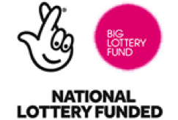
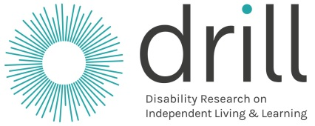

About DRILL 2nd Call

How to ask DRILL for money
for your project
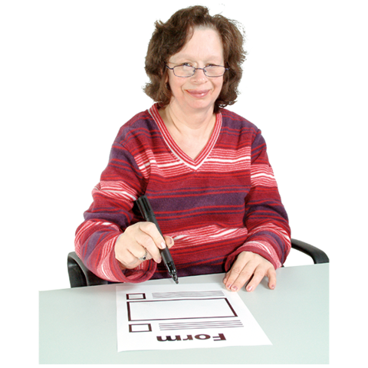

What is in this booklet?

 | Page
Part 1 About DRILL  - About this booklet  - What is DRILL and why is it important? | 4  5
Part 2 What DRILL can give money for  - The main things to know  Rules for DRILL projects:  - What sort of projects we can give money for  - What your project can be about  - The things we want DRILL to do  - Other things to think about | 8  10  13  18  19
Part 3 Asking DRILL for money  - How much money we can give  - What to do now  - What happens next | 27  27  27  27  23  24  25
 | Page
Part 4 Support and Information  - Support you can get  - Other information about DRILL  Information to help you  - Information to help you  - What hard words mean  - Tips for making sure people can be part of your project | 33  27  37  35  34  27  27  27  27  27  27

Part 1 About DRILL

About this booklet

This stage of DRILL is called the 2nd Call.

This booklet will tell you about DRILL and how to ask DRILL for money for your project.

Please read these notes and the Questions and Answers booklet before you start.

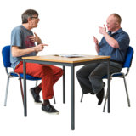

You can ask for support with anything in this booklet.
What is DRILL and why is it important?

DRILL is short for:
Disability Research on Independent Living and Learning.

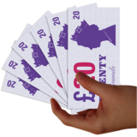
DRILL gives money for important projects to help disabled people make choices about how they live.

A project is a piece of work that helps to change something.

DRILL is different because disabled people have a big say in everything that happens.

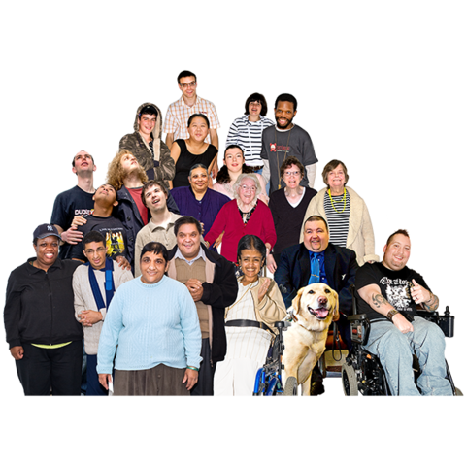
Why is DRILL important?

We want all disabled people to have a good life.

We want disabled people to be able to make choices about how they live.

This means they should be able to:

- join in and do things

- do the things they want to do, with support if they need it

- make choices about things like where to live and who to live with

- have the best life they can

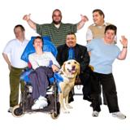
We will give money for work that helps disabled people make choices about how they live.

This is called Independent Living.

It is what DRILL is about.

This is the last time people can ask us for project money in this way.

After this we will only look at certain projects that disabled people say should happen.

Part 2 What DRILL can give money for

The main things to know

We want to give money to projects that:

- have new ideas about how to make life better for disabled people

- are about disabled people’s ideas and what they think is important

- are about disabled people and other people working well together

- find out really good information that people can trust and use to make good decisions

We want to give money to projects that:
- solve problems and help really change things now and in the future

- think about what different groups of disabled people need and what life is like for them

- are done in a good way and are fair for everyone

- help people learn from each other and do well

- use money in the best way

Rules for DRILL projects

What sort of projects we can give money for

There are 2 types of projects we can give money for:

- Research. This is finding out more about something

- Pilot projects. This is testing something out to see how it works

We would most like to give money to pilot projects.

But we will look at good research projects too.

There is more information about research and pilot projects on the next pages.

- Research projects

Research is when you look into something to find out more about it.

For example, you could look into jobs for disabled people.

People can use the information you find out to see what works and make
important decisions.

Your research project will:

- find out more about something

- help you think of new ideas
or ways to make life better
for disabled people

- Pilot projects

This is when you test an idea
that could make life better for disabled people and really change things.

You may want to test something from information that is already there.

Or you may have a new idea to test out.

But it must be a very good idea.

And there must be information to show it is a good idea.

You will see how the idea works in real life.

What your project can be about

Your project must be about helping disabled people have a better life.

This is called Independent Living.

There is more information about this on pages 6 to 7.

Your project must be about one of the 4 things starting on the next page.

They are called Themes.

Your project can be about any of these 4 things.

But we would most like to give money to projects that are about:

- Theme 1. Work, jobs and buying things you need
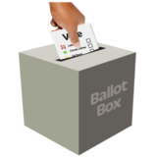

- Or Theme 2. Voting and other important decisions

The 4 themes are:

- Work, jobs and buying things you need

This is about making sure disabled people
can:

- have a job or set up a business

- do well in their jobs and get paid well

- buy the things they need and use the services they need

- get good education, training and skills

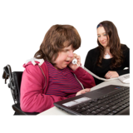
We would most like to give money to projects that help disabled people:

- set up their own business

- or get a job and get paid fair money for their job

- Voting and other important decisions

This is about making sure disabled people can:

- make decisions about the local area or country

This means helping to make big laws and plans too

- have the skills to be in charge of things and make decisions

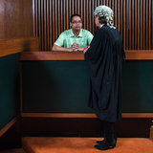
We would most like to give money to projects that make sure disabled people:

- get the right support from the police, courts and prisons and can take part in things to do with the law

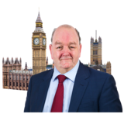
- are treated fairly by staff in places like mental health hospitals or care homes

- or can take part in politics and do well

- Being part of the community

This is about making sure disabled people can:
- go out, meet people and join in with things

- do the things they want to do in their local area
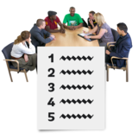

- say what services should be like

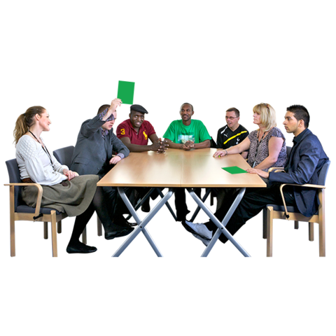
Services can be lots of things like health care, transport and schools

- have their say and be listened to

We would most like to give money to projects that help disabled people:

- get the right support, money or housing to live in the way they choose

- Things that can help disabled people take part in everything
Some examples are:

Peer Support
This is where disabled people work together and support each other.

Making choices
This is about disabled people being able to choose what is best for them.

Easy information
Information that is easy to understand helps disabled people join in with things and make decisions.

We would most like to give money to projects that help disabled people:
- be happy and well and have good relationships
- travel around more easily
- or be less poor
The things we want DRILL to do
They are called outcomes.

Your project must help with 1 or more of these things:

- Your project will help people learn about what is important to disabled people.

You will find out new information about how to make life better for disabled people.

- Your project will help disabled people have a big say in laws, plans, services and other decisions.

- Your project will help disabled people have a better life by taking part in your project.

- Your project will help people in charge make good decisions about things like plans and services for disabled people.

Other things to think about
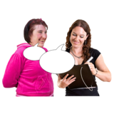

How to do your research

For example, will you interview people, ask them to fill in a survey or something else?

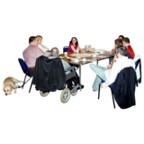
Who you need to work with

These people need to be part of your project:

- disabled people or groups of disabled people

- people who know a lot about research or testing things to see if they work

- anyone else that will be good to work with

Most of the time you will need to work with other people or groups.

What do we mean by disabled people?

Disabled people can mean:

- all kinds of people who feel they are disabled

- people who have an illness for a long time like cancer or dementia

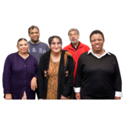

Your project can be about all disabled people or a certain group of disabled people.

But you need to think about all the people you will help.

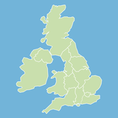
For example, will your project help
disabled people from different places?

Or people with different types of disability?

Making sure disabled people are a big part of the project

Disabled people must be a very big part of your project.

Your project must be about their ideas and what is important to them.

We want projects where disabled people and other people work together.

For example, where disabled people work with people who know a lot about research.

This means:

- everything should be easy for disabled people to take part in

- disabled people should have the same say as everyone else
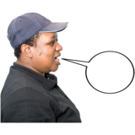
- your project should treat disabled people with respect and talk about disabled people in the right way

- you should use the language that disabled people want to use to talk about themselves
Where your project takes place
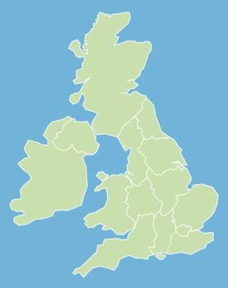
Your project can be for work in Scotland, Wales, England or Northern Ireland.
Scotland
Northern Ireland

Or more than one country.
Wales
For example, England and Wales.
England

The information you give us

We will ask you for information about who your project will help.

This will help us know if we are doing things right and if we need to change anything.

It will help you know if you are helping the right people.

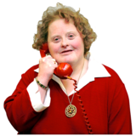

We may ask you to make some changes if we think your project could help more people or there is a better way to do things.

Part 3 Asking DRILL for money

How much money we can give

There are 3 types of money we can give:

Small research projects: Up to £40,000 each

Large research projects: Up to £100,000 each

Pilot projects (to test out new ideas): up to £150,000 each

What to do now

Please fill in the 2nd Call Application Form.

If possible please fill in the form on the internet at:

http:/www.drill.flexigrant.com

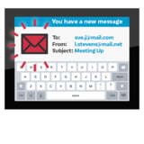
If you want to give us your form in another way please tell us.

Email Jacquie:
jacquelineritchie@disabilityaction.org

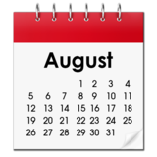
When to send us your 2nd Call form

You must send us your form by Tuesday 8 August 2017 at 12pm (lunchtime).

What happens next?

- DRILL will check some things on your form first to see if everything looks OK.

- Your form will then be looked at by a group called a National Advisory Group.

There is a group like this for each country.

They will look at the forms for their country.

They will choose some projects that they think are good.

3. A group called The Central Research Committee will make the final decision about what projects to give money to.

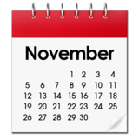

4. We will send you a letter to tell you if we will give you money or not. We plan to do this in November 2017.

5. If we give you money, we will send you a letter with some rules.

You need to agree to these rules first.
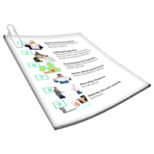

You will also need to make a document about how you will work with people in your project.

We need to agree to this document first.

Part 4 Support and Information

Support you can get

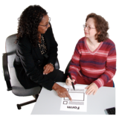
There is a person who can give you some support.

They are called a DRILL Programme Officer.

There is one for Scotland, Wales, England and Northern Ireland.

What the DRILL Programme Officer can help with

They can help with things like:

- making information about DRILL easier to understand

- any questions you have about this booklet, the 2nd Call application form or the Questions and Answers booklet

- finding someone to help you if they cannot help

- support with what to do if we give you money

They cannot do things like fill in the form for you or tell you how to make it better.
How to get in touch with your DRILL Programme Officer
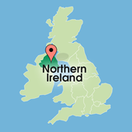
Northern Ireland

You need to speak to:

Fiona McMahon

DRILL Programme Officer

Disability Action.

fionamcmahon@disabilityaction.org

Phone: 028 9029 7880

Textphone: 028 9029 7882

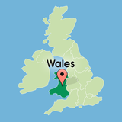
Wales

You need to speak to:

Jody Mellor

DRILL Programme Officer.

jody.mellor@disabilitywales.org

Phone: 02920 887325

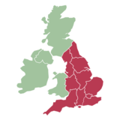
England

You need to speak to:

Evan Odell
DRILL Programme Officer
Disability Rights UK

evan.odell@disabilityrightsuk.org

Phone: 020 7250 8198

Scotland
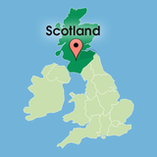
You need to speak to:

Rosalind Tyler-Greig

DRILL Programme Officer
Inclusion Scotland

Email Rosalind:
rosalind@inclusionscotland.org

Phone: 0131 281 0859

Other information about DRILL

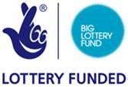
Money for DRILL comes from a group called the Big Lottery Fund.

There are 4 groups in charge of running DRILL.

They are:
- Disability Action (Northern Ireland)

- Disability Wales

- Inclusion Scotland

- Disability Rights UK (England)

Information to help you

Information to look at

1. There is a document about the rights of disabled people.

It is called the:
United Nations Convention on the Rights of Persons with Disabilities (UNCRPD)

It is in easy read on this website:

www.gov.uk/government/uploads/system/uploads/attachment_data/file/345108/easy-read-un-convention.pdf

2. There is some easy read information about how disabled people and other people can work together in a good way.

It is on this website:
http://bit.ly/ILIScopro2

3. Our website is www.drilluk.org.uk

What hard words mean

Word | What it means
Funding  Applying for funding | Money for a project  Asking for money for your project
Outcome | What change will happen because of your project.  What your project will make better
Theme | The subject your research is about
Pilot project | A project to test something out to see if it works
Research | Looking in to something and finding out more about it
Word | What it means
Independent Living | When disabled people have the same chances as everyone else.  When they can do things like:  - make their own choices. Like where to live, friends, health and support  - do the things they want to do, with support if they need it  - join in with the things everyone else does  - have the best life they can
Services | There are lots of services in your local area like healthcare, transport, schools and the Police

Tips for making sure people can be part of your project
- Start planning early

- Find out more about the people you want to work with, what they need and any problems they may have taking part

- Find out how they like their information

- Think about how to make it easy for them to take part, like:

- the best place, date and time for meetings

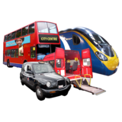
- how easy it is for people to get there and how much it may cost

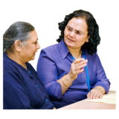
- what support people need to take part

- how they can trust you
Pictures by Photosymbols

